**Server Side Architecture**

**Node** – javascript runtime used to execute code outside of the browser

**Express** – library that runs in the Node runtime. Has helpers to make dealing with HTTP traffic easier

**HTTP Request/Response Cycle**

**Node** is listening for incoming HTTP **request** from specified **port**, and then passes it off to **Express** side of app. Node is core aspect, and handles all HTTP traffic.

**Express** looks at the **request** and decides what chunk of **code** will “**handle**” or **respond** to the request. In Express, we write collections of **route** **handlers** to **respond** to incoming HTTP **requests**. (e.g. one handler might authenticate a user, one might log out a user, allow user to create/save, etc.)

Route handlers then generate an outgoing HTTP response. This response will then be sent back to running Node process, and Node will then respond to incoming request with response that we author. Ultimately, the response will be sent back to whoever made that HTTP request.

**Initial Setup**

In terminal:

1. Create package.json: **npm init**
2. Create Express dependency: **npm install --save express**
3. Create first express server and new route handler: **touch index.js**

**Setup Express**

In index.js:

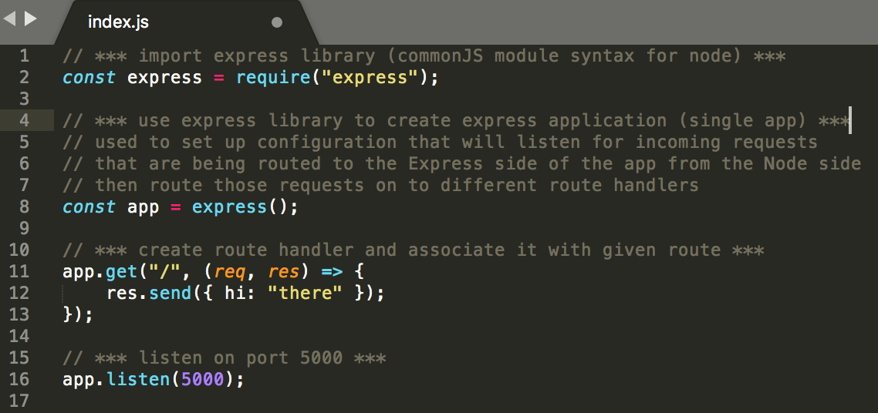

**Run Server**

In terminal: **node(mon) index.js**

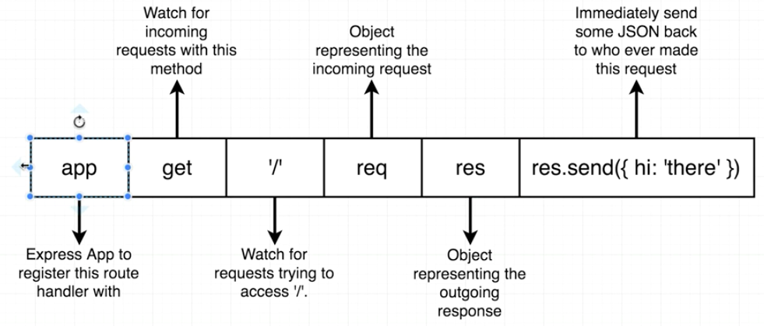

**Request Methods:**

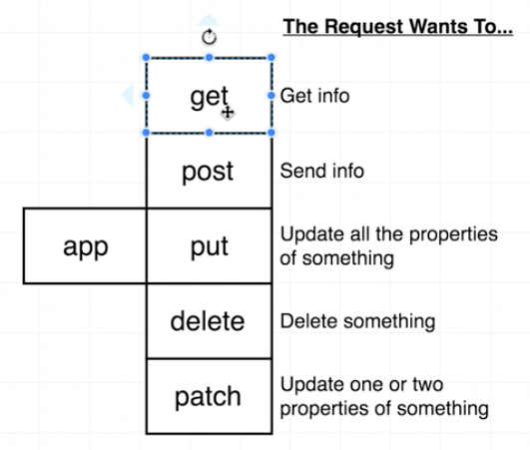

**Deployment**

Using **heroku.com:**

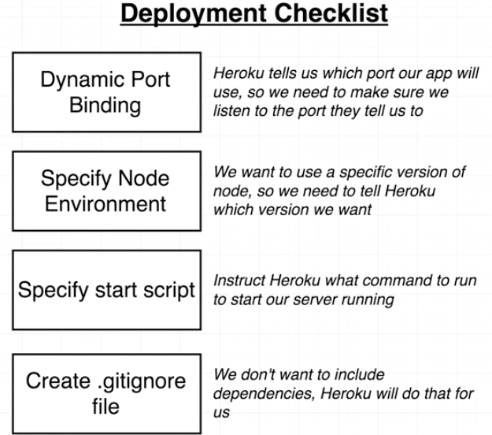

**Dynamic Port Binding**

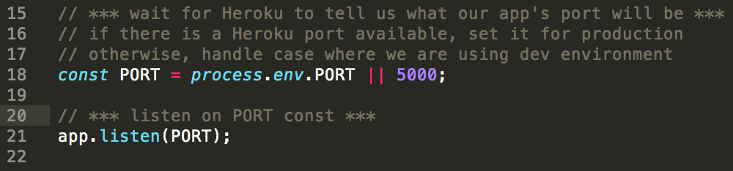

**Specify Node Environment and Specify Start Script**

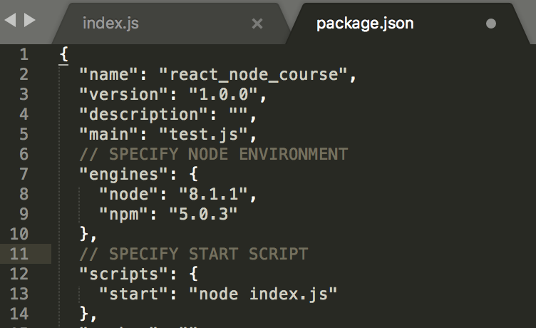

**Create .gitignore file**

* In terminal: **touch .gitignore**
* In .gitignore: **node_modules**

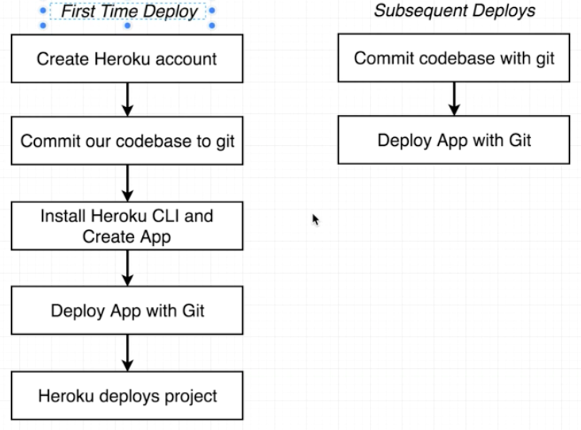

**Create Heroku App**

In terminal:

1. **Heroku login**
2. **Heroku create**



* First link is the address we will use to visit in browser (string is randomly generated)
* Second link is **deployment target** (Git repository that we can push our local server to)

**Deploy App with Git**

In terminal:

1. **git remote add heroku <link>** (<https://git.heroku.com/aqueous-chamber-85621.git>)

*(adds remote repo to our current repository with name heroku)*

1. **git push heroku master** *(take all code that we committed to local repo and push master branch to heroku repo which exists at above url)*
2. **heroku open** *(opens browser window with deployed project)*

**If errors: **heroku logs**

**Subsequent Deployments**

1. Make changes and save
2. **Git add .** and commit
3. In terminal: **git push heroku master**

**Authentication with Google OAuth**

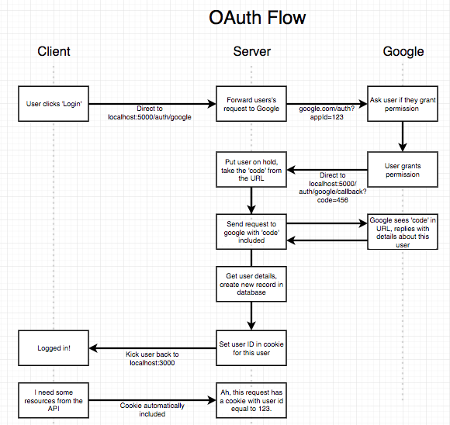

**PassportJS**

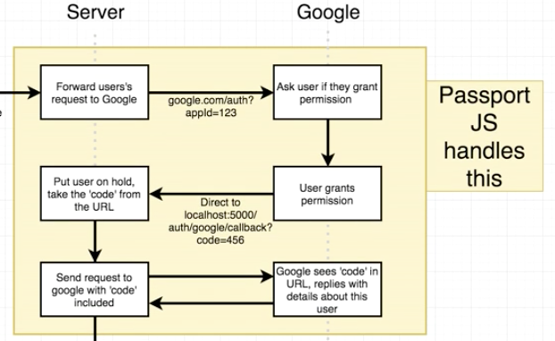

**Issues to be aware of with passportJS:**

* While passportJS automates authentication flow, it still requires us to add code to make it work properly
* Have to install at least 2 different libraries:

1. **Passport**
2. **Passport** **strategy** (1 for each type (i.e. Facebook, Google, email/password, etc.)

*(a strategy is a module that helps authenticate with one very specific provider)*

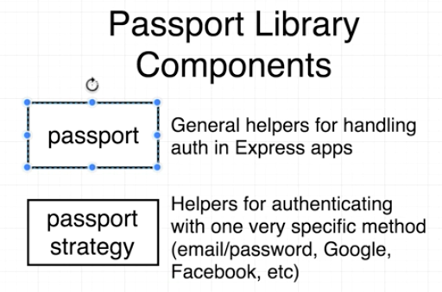

**Install passportJS**

In terminal:

1. Install passport and 1 passport strategy:

**npm install --save passport passport-google-oauth20**

1. Import passport and passport strategy:

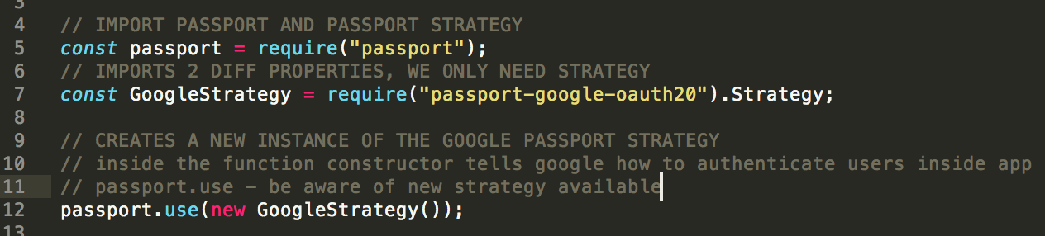

**Generate brand new project to use with Google OAuth API**

1. Navigate to: [console.developers.google.com](http://console.developers.google.com/)
2. Click “Create Project” at top-right
3. Add project name and create *(takes a few moments)*
4. Create new API credential: Click “Enable APIs and Services”
5. Search for “google+ API” and click
6. Click “Enable” at top
7. Generate API credential: “Credentials” tab under “Library” on left nav-bar
8. Click “Create credentials” drop-down and select “OAuth client ID”
9. Click “Configure consent screen”
10. Fill out Product name shown to users *(e.g. emaily-dev)*
11. Click “Save”
12. Select Application type (i.e. Web Application)
13. Fill name (or leave it)
14. Fill out Authorized JS origins: http://localhost:5000
15. Fill out Authorized redirect URIs: http://localhost:5000/auth/google/callback
16. Click “Create”
17. Modal appears with tokens that will need to be secured with instructions below

**NOTE: **DO NOT PUSH CLIENTSECRET TO GITHUB!!!**



**Secure Tokens**

1. Create “config” folder in server directory
2. Create new file in config dir: **keys.js** *(all sensitive keys will be stored here)*
3. Copy client ID & client secret and paste into **keys.js** with code below:

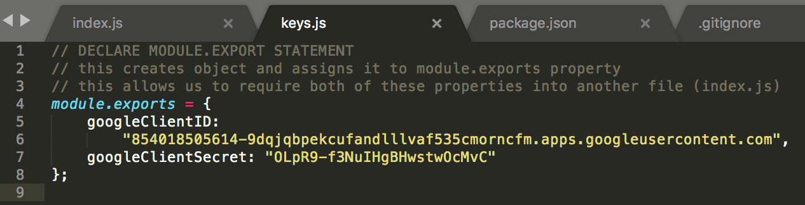

1. In .gitignore file add file name: **keys.js**

**Import keys.js module into index.js and pass to GoogleStrategy function**

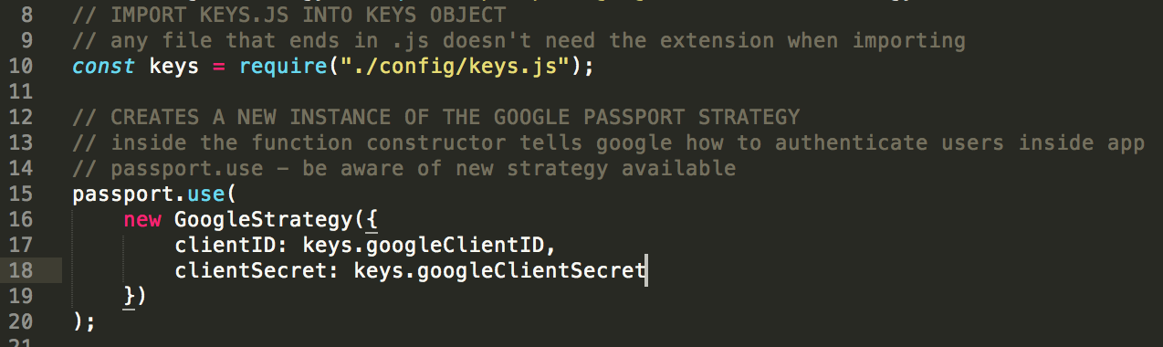

**Configure route that user will be redirected to after they grant permission to the app**

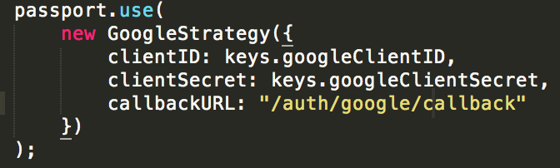

**Setup route handler for when “/auth/google” is visited**

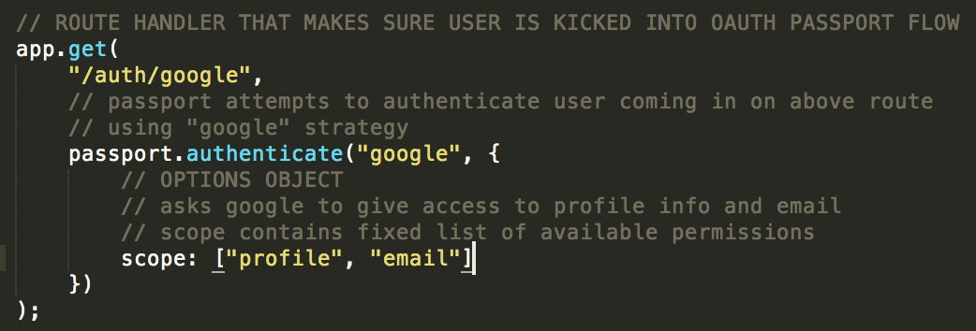

**Console log tokens and profile**

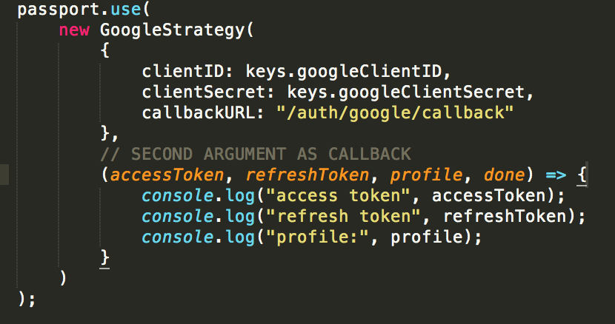

**Set up route handler for code exchange**



**Start up server in development mode for nodemon**

In package.json:

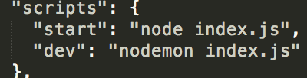

In terminal: **npm run dev**

**Adding MongoDB**

**Server Structure Refactor**

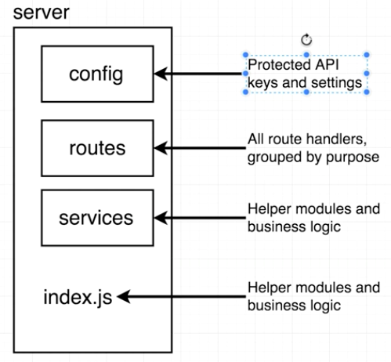

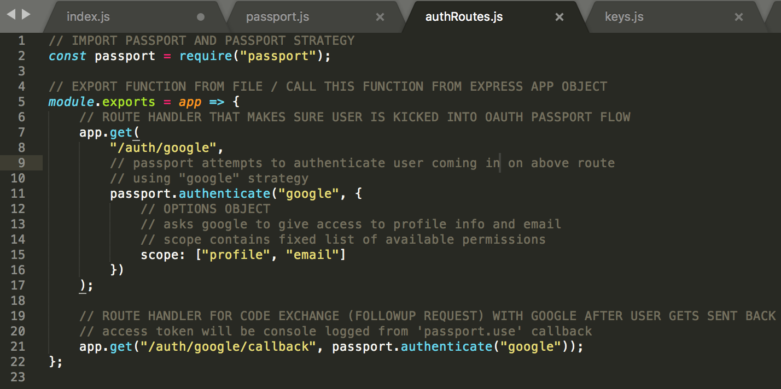

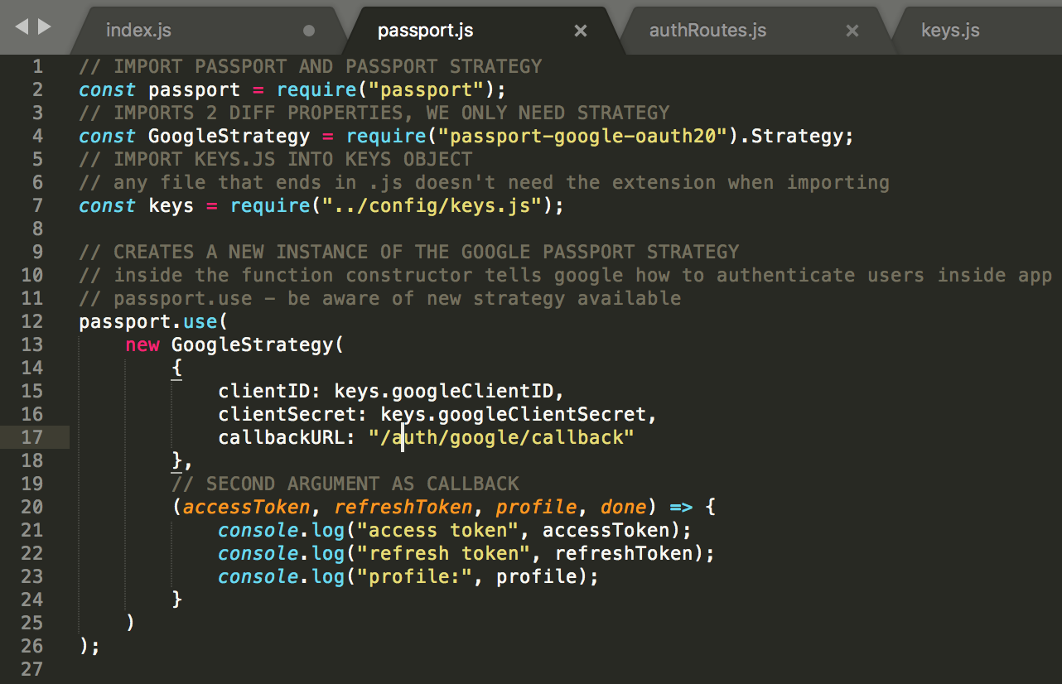

In **index.js** we can replace top lines of code with the bottom code:

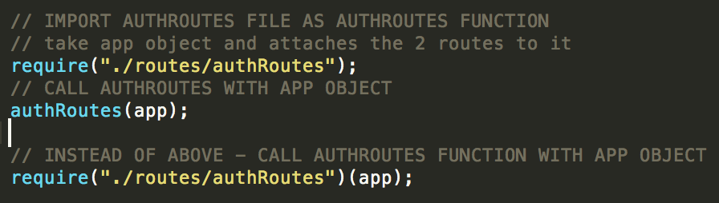

**Theory of Authentication**

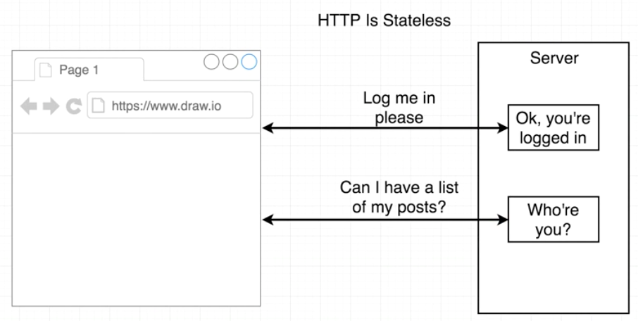

**HTTP is Stateless** 🡪 between any two given requests we make, HTTP inherently has no way to identify or share information between separate requests

**How do we get around this?** Authentication schemes

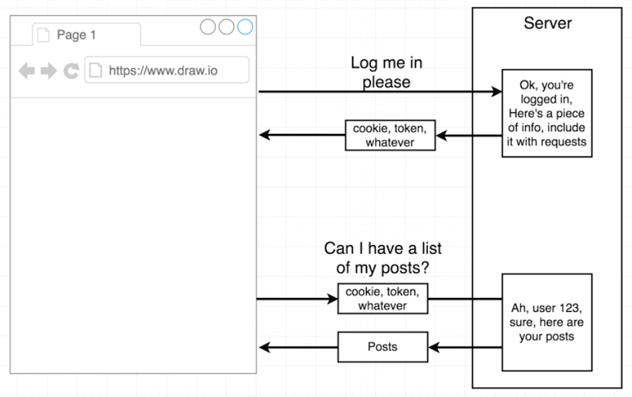

**Cookie-based authentication**

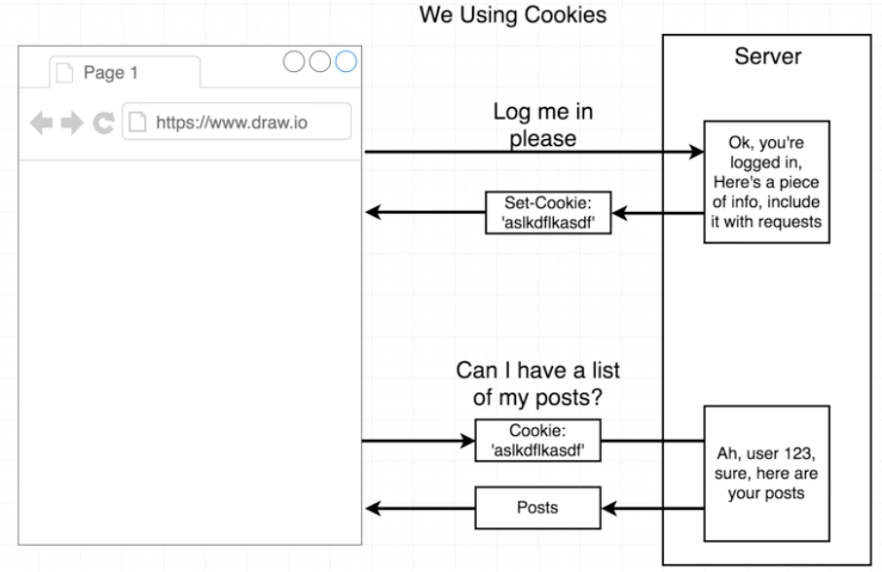

Response back from server contains a header with a property called “**set cookie**” set to some random token, which will be used to uniquely identify user.

Browser strips off token and stores it into browser memory, and then browser automatically appends that cookie with any follow-up request being sent back to server.

**Signing in users with OAuth**

|  |  |
| --- | --- |
| ../../../../../../../Desktop/Screen%20Shot%202018-06-21%20at%204.4 | ../../../../../../../Desktop/Screen%20Shot%202018-06-21%20at%204.4 |

Use google’s profile ID as identifier

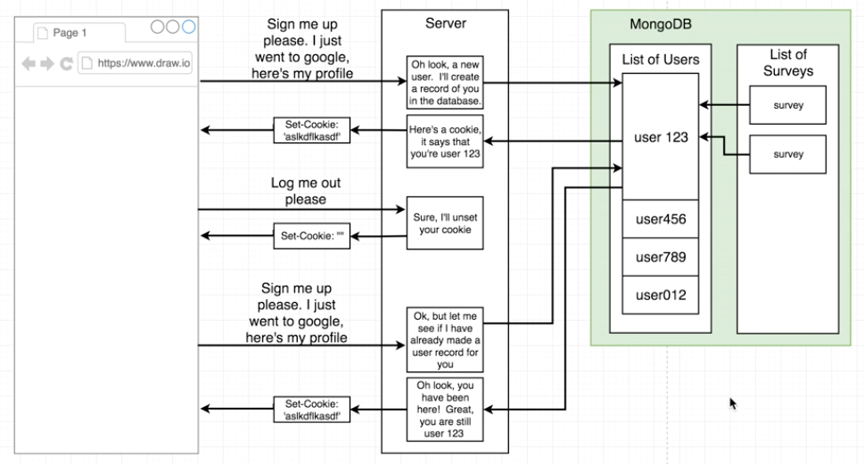

**Intro to MongoDB**

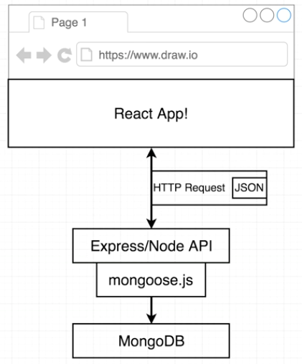

MongoDB is **schemeless** meaning it doesn’t have to have a particular schema.

In other words, each object doesn’t have to have the same property.

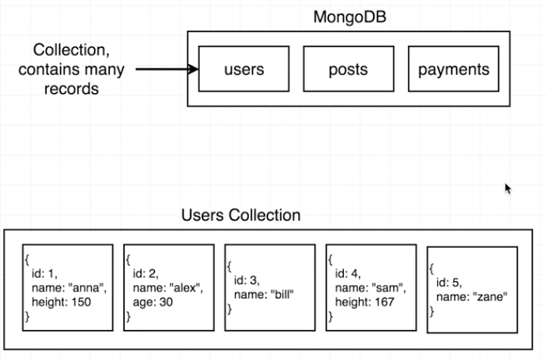

Model class/instance are from **Mongoose**

Searching uses a **model class**

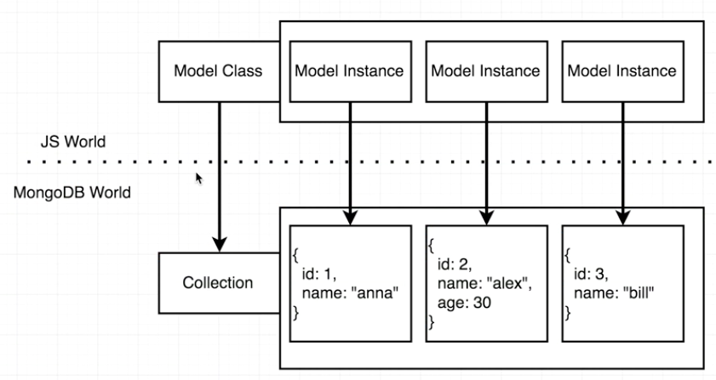

**MongoDB Setup**

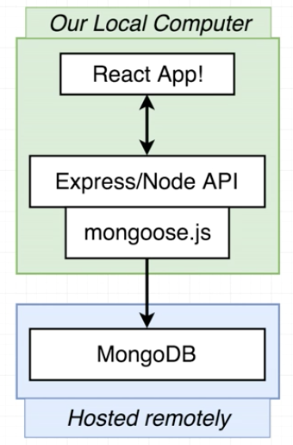

**Create sandbox db with mlab**

1. Login in to mlab.com
2. Click “Create new”
3. Choose AWS
4. Select free Sandbox and click continue
5. Choose region and click continue
6. Name database (e.g. emaily-dev)
7. Leave version as default and click continue
8. Submit order
9. Click on database to expand for dashboard

**Create database user**

1. In dashboard, click “users” tab
2. Click “Add database user”
3. Fill out information
4. Make sure “read-only” is NOT checked and click “create”

**Connecting Mongoose to Mongo**

1. In terminal: **npm install –save mongoose**
2. Import mongoose in index.js:  **const mongoose = require(‘mongoose’);**
3. Copy MongoDB URI from:

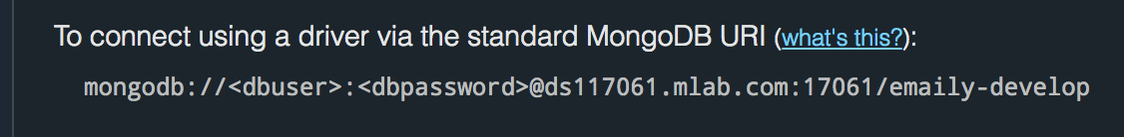

1. Paste into following code in **keys.js** as seen below:

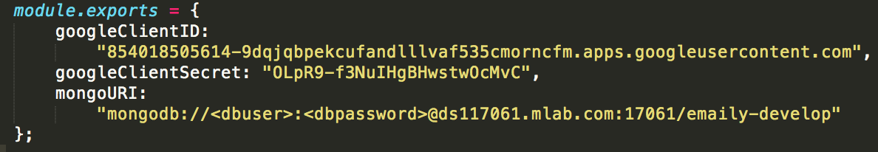

1. Change MongoDB URI **dbuser** and **dbpassword** above to that of database user
2. Import keys.js into index.js (in index.js): **const keys = require('./config/keys');**
3. Instruct mongoose to attempt to connect to mongoDB: **mongoose.connect(keys.mongoURI);**
4. In terminal: **npm run dev**

**Review**

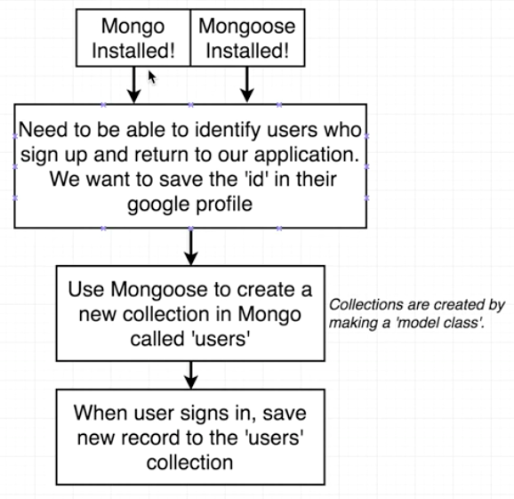

**Mongoose Model Classes**

**Create model class**

1. Create new ‘**models’** directory that will contain model classes we create with mongoose
2. In ‘models’ directory, create new file called: **User.js**
3. In *user.js*, import mongoose: **const mongoose = require("mongoose");**
4. Pull 1 property off of mongoose variable we just created:

**const Schema = mongoose.Schema;**

or we can *destructure* the same line to be:

**const { Schema } = mongoose;**

**Create new collection**

1. Set up User.js like below:

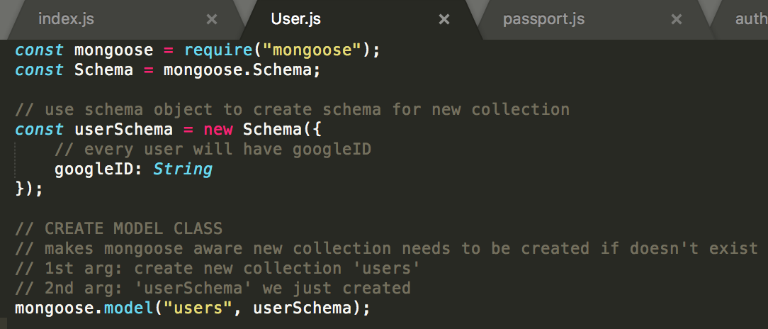

1. Import in index.js without assignment: **require("./models/User");**

**Saving Model Instances**

1. In passport.js, import mongoose library: **const mongoose = require("mongoose");**
2. In passport.js, give access to *user model class*:

**const User = mongoose.model("users");**

*\*\*note: one argument means we’re trying to fetch out of mongoose, second means we’re trying to load something into it*

1. In passport.js: **new User( { googleID: profile.id }).save();**

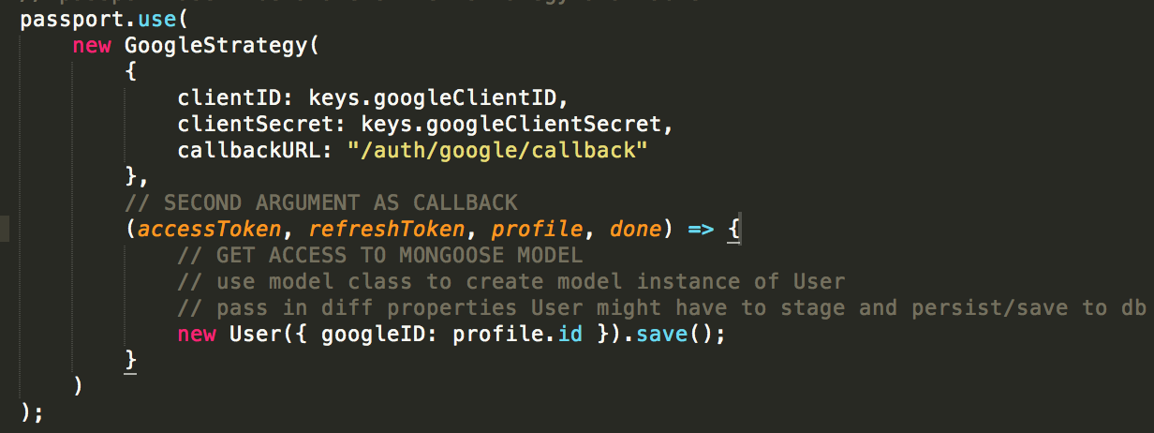

1. Make sure in index.js that order of imports is correct. Error appears because we are trying to make use of User model before we actually defined it:

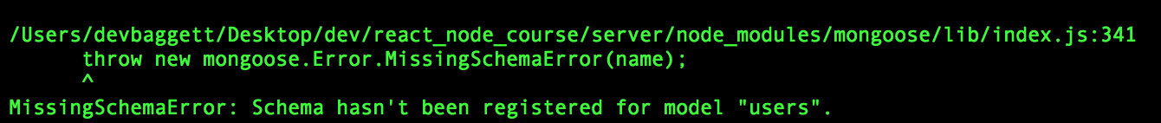

Correct order to make error go away:

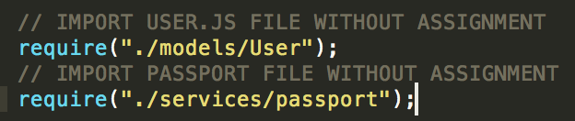

1. If done correctly you should see the following on mLab. Click on users and you will see list off all records that exist inside that collection:

|  |  |
| --- | --- |
| ../../../../../../../Desktop/Screen%20Shot%202018-06-21%20at%207.2 | ../../../../../../../Desktop/Screen%20Shot%202018-06-21%20at%207.2 |

**Mongoose Queries**

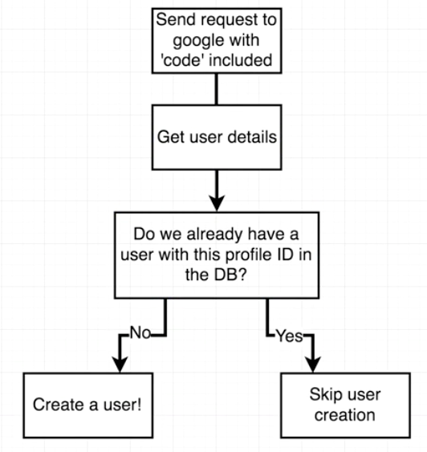

**Skip user creation if user already exists (avoid duplicate entries)**

In passport.use function in passport.js file:

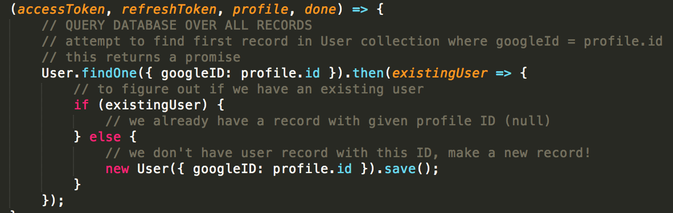

**Passport Callbacks**

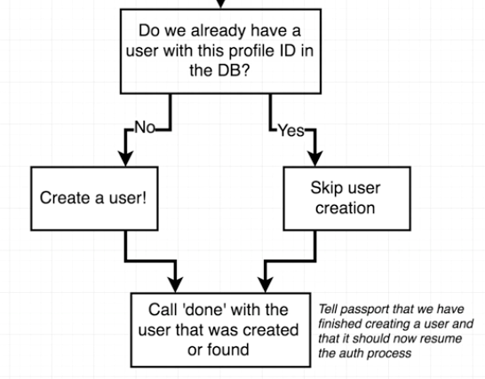

Notice “done”:

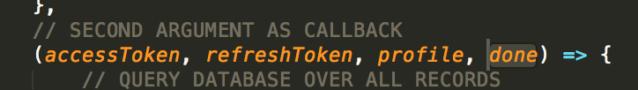

In **if** conditional side, call ‘done’ function, and provide 2 arguments:

1. air object 🡪 communicates back to passport that something went wrong or not as expected. However, if a user is found in users collection, that means everything went fine, therefore we pass in **null**.
2. User record 🡪 **existingUser**

In **else** side, we don’t want to call the ***done*** function until we know for a fact the user has been saved to the database. Any time we save a record to the database it is an *asynchronous*operation. So in order to get something to confirm that user was saved, we have to chain on a **.then** statement (*promise callback*) which will be called with the new user that was just saved.

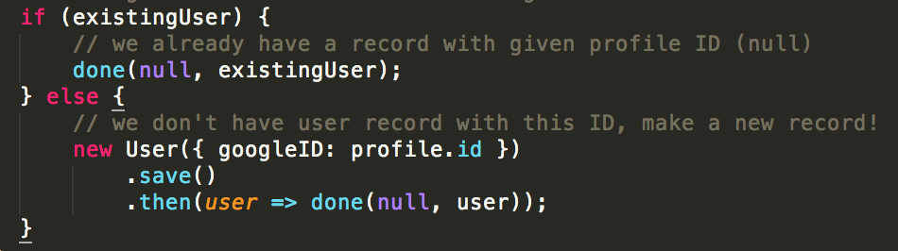

The promise callback contains the same user we just saved, but fresh from the database.

**Encoding Users**

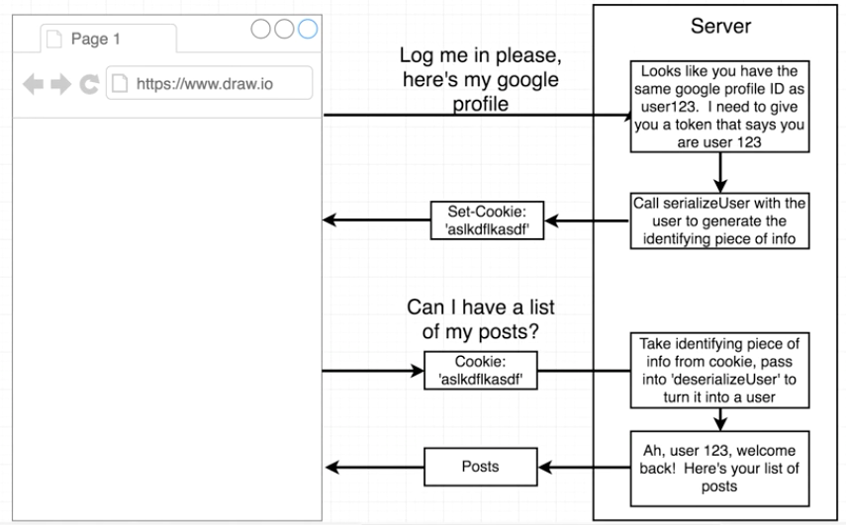

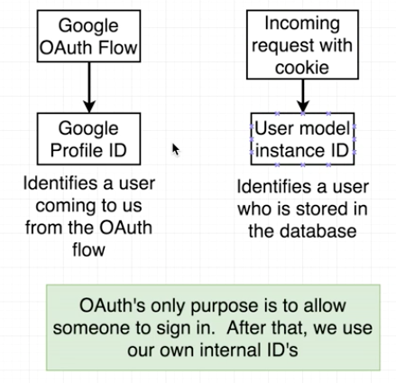

This is why we use **user.id** instead of **profile.id** as seen below in **passport.js** file:

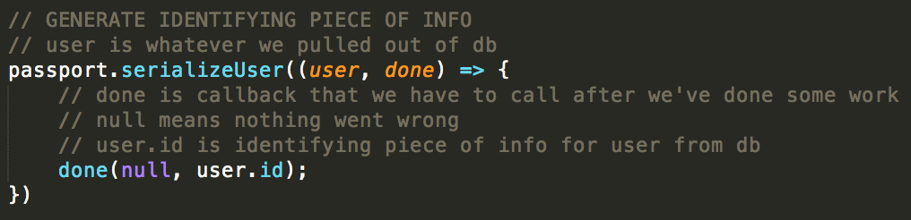

**Deserialize User**

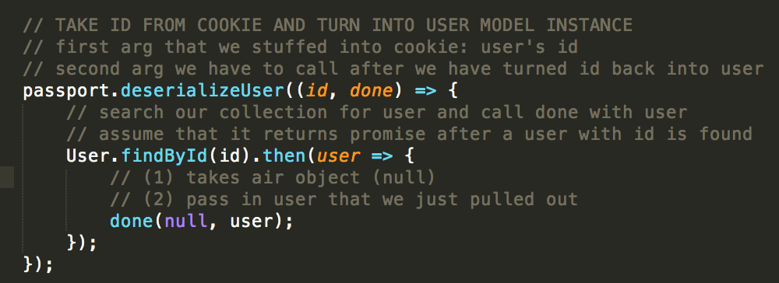

**Enabling Cookies**

1. In terminal: **npm install --save cookie-session**
2. Tell Express it needs to make use of cookies within app. In **index.js**:

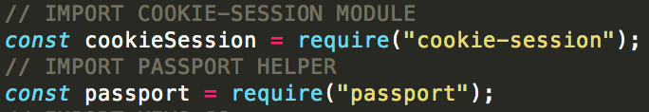

1. In **keys.js**, create random **cookieKey:**

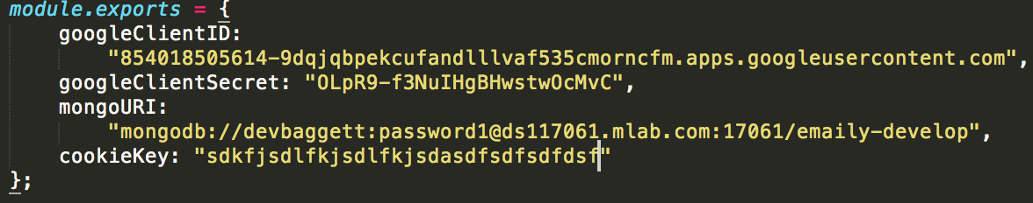

1. In **index.js**, enable cookies and pass **cookieKey** into **keys** property:

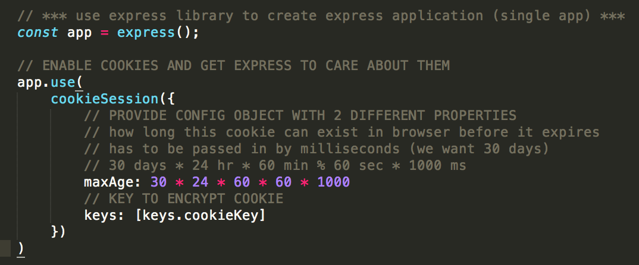

1. Right below:

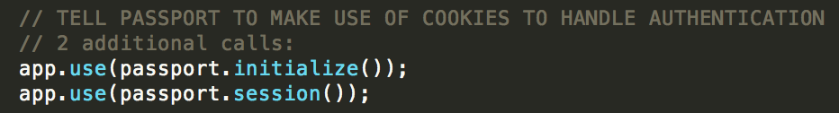

**Testing Authentication**

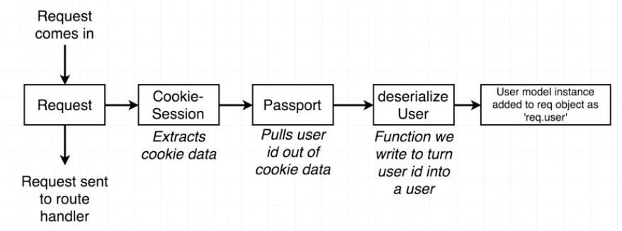

** passport is pulling data out of **req.session**

1. In **authRoutes.js** provide new route handler for get requests after user has already gone through the OAuth flow:

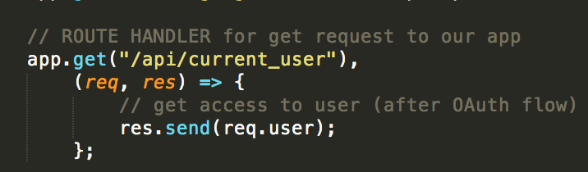

** user JSON should show up

1. Logging out, in **authRoutes.js**:

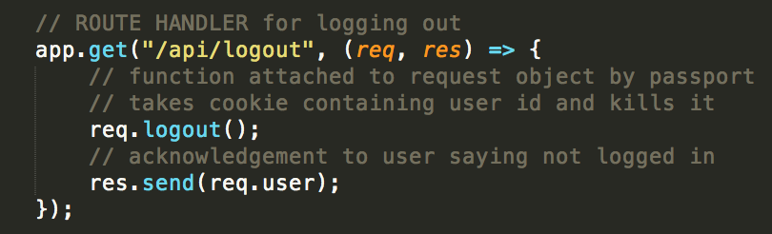

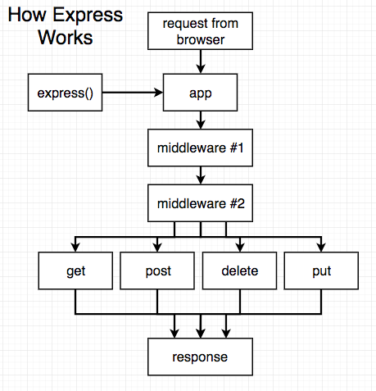

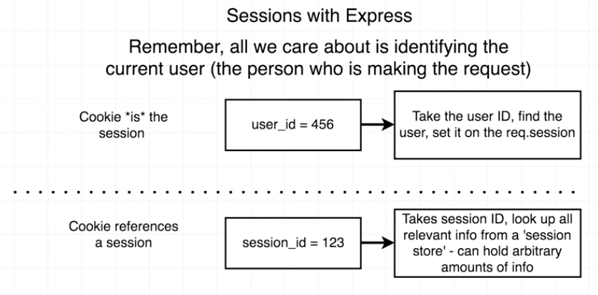

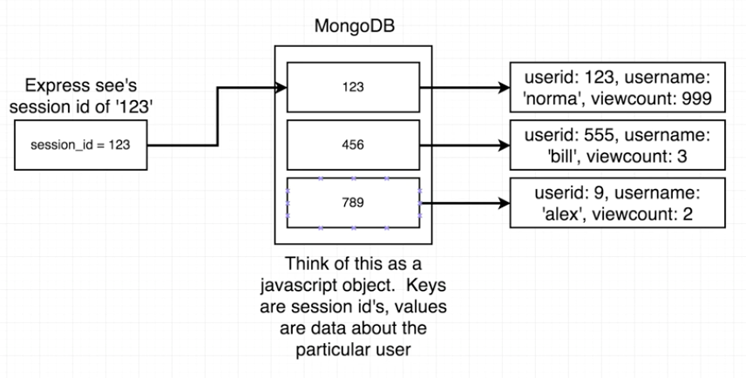

** express-session creates a session cookie with ID referencing where all data is stored remotely, whereas cookie-session stores all that data in the cookie

**Why use one or the other?**

With express-session we can store as much data we want to. With a cookie we are limited to about 4k.

**Dev vs Prod Environments**

**Dev vs Prod Keys**

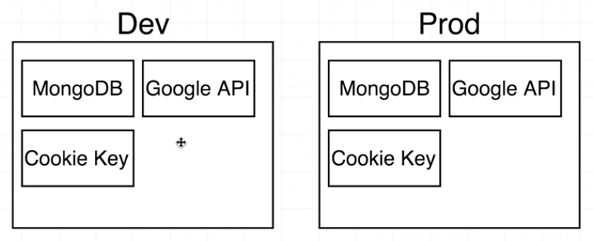

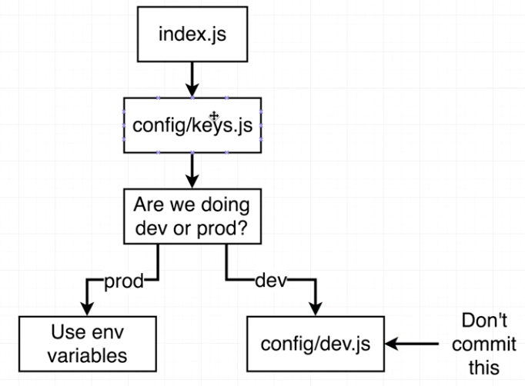

**Generating Production Resources**

1. Create new mongoDB:

* In mLab create a new database (I.E. emaily-prod, emaily-prod-env)
* After created, goto Users tab and add a new database user (different name from dev)

1. Create production environment’s Google API:

* Go to: <http://console.developers.google.com/>
* At drop-down at top, click and click on ‘new project’
* Name it (I.E. emaily-prod) and click ‘create’
* Go back to drop-down selector at top and click on created project
* Click on ‘enable API’
* Search for ‘google+’ API and click
* Click ‘enable’
* Click ‘credentials’ on left nav-bar
* Click ‘Create credentials’ with OAuth client ID
* Click ‘configure consent screen’
* Fill out product name to be shown to users (I.E. Emaily, not Emaily-prod)
* Click ‘save’
* Choose ‘web application’ and click ‘create’
* We can leave name the same if we want
* To find heroku url, in terminal for server: **heroku open**
* Select and copy address and paste in ‘Authorized redirect URIs’ field with ‘/auth/google/callback’ amended to end
* For ‘Authorized JavaScript origins’ paste same url without ‘/’ at end
* Click ‘Create’

1. Set up **keys.js** for both prod and dev environments. **Keys.js** will now only only contain logic to point to which set of keys to use when committing to Git:

* In **config** folder make a new file: **dev.js**
* Cut everything out of **keys.js** and place into **dev.js**
* Comment at top of **dev.js**: **// dev.js – don’t commit this**
* Comment at top of **keys.js: // keys.js – figure out what set of credentials to return**
* Create new file in **config**: **prod.js** (// prod.js – production keys here)
* In keys.js:

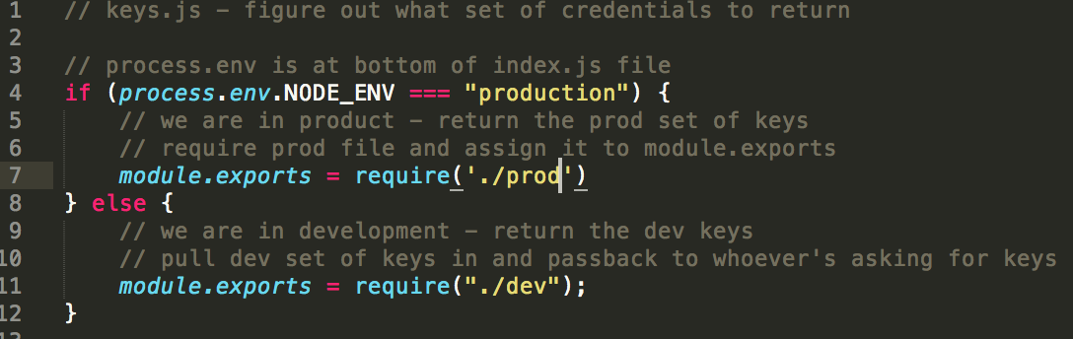

* Copy from dev.js to prod.js the module.exports code and delete the values for each key
* Whenever prod.js is required in prod environment or heroku the values for each of the keys are pulled from heroku environment variables:

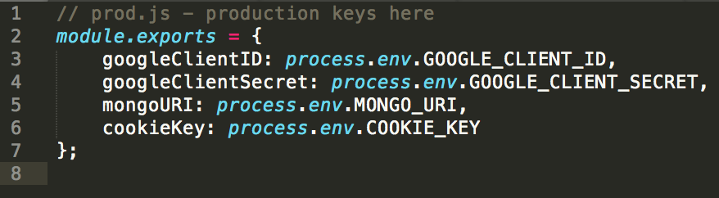

* We want to make sure now that we commit the **prod.js** file when we push our app to Heroku
* Change **.gitignore** file to now ignore:

1. Node_modules
2. Dev.js

**Heroku Environment Variables**

Make sure env variables are defined on server:

1. Open up tab and navigate to *heroku.com*
2. Click on app
3. Click on ‘Settings’
4. Click on ‘Reveal Config Vars’
5. One by one, add in key and respective value.

* From prod.js copy key (I.E. GOOGLE_CLIENT_ID) and paste into Heroku vars key
* From Google API that we just created, copy and paste the associated client ID into the respective Heroku vars value
* Click ‘Add’
* Same process for the GOOGLE CLIENT SECRET
* ‘COOKIE_KEY’ value can be arbitrary string
* For ‘MONGO_URI’ copy from mlab, the MongoDB URI with associated login/password amended. Tip – paste and add credentials in separate window:

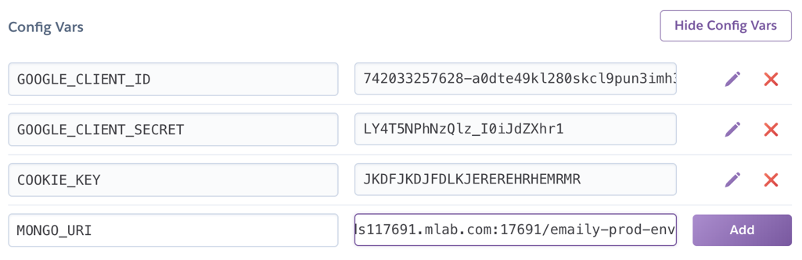

* After adding all config vars, click ‘Hide Config Vars’

1. Deploy app on Heroku:

* Commit codebase with Git
* Deploy App with Git: **git push heroku master**

1. Test in browser, in terminal: **heroku open**
2. Kick off Oauth flow again – Should be error with http/https when navigating to the url + /auth/google:

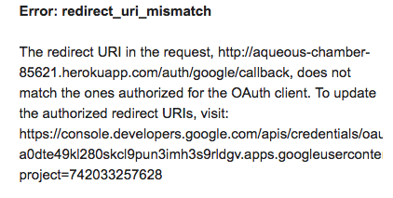

* There is a relative path for callbackURL in passport.js:

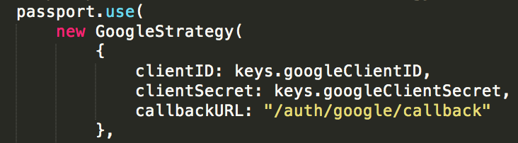

* See below for proxy fixes

**Fixing Heroku Proxy Issues**

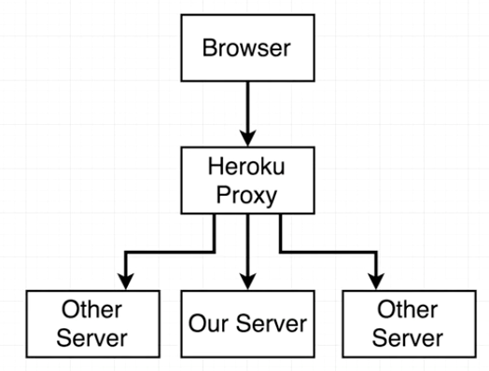

**There are two ways to fix the error from above:**

1. Tell google strategy to trust proxy from Heroku
2. Write in the full URL into callbackURL for both prod and dev

Using the relative path rather than creating another runtime decision so choose option (1) and add a trust proxy line:

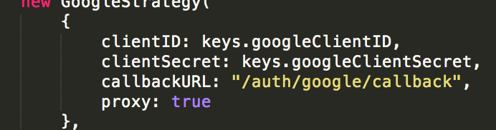

**Test by going through OAuth flow again, then going to relative path: **/api/current_user**

**Moving to the Client Side (React)**

**React App Generation**

**Install Create React App tool:**

1. Google search ‘create react app’ and click on facebookincubator GitHub link for documentation
2. In terminal, install globally: **sudo npm install –g create-react-app**

**Generate new project within server directory:**

1. In terminal: **create-react-app** <name> (I.E. create-react-app client)
2. After installing, should see new folder: **client**
3. This project we just created has its own built-in **server**

**A Separate Front End Server**

**Start server:** In ‘client’ dir (or project we just created), in terminal: **npm start**

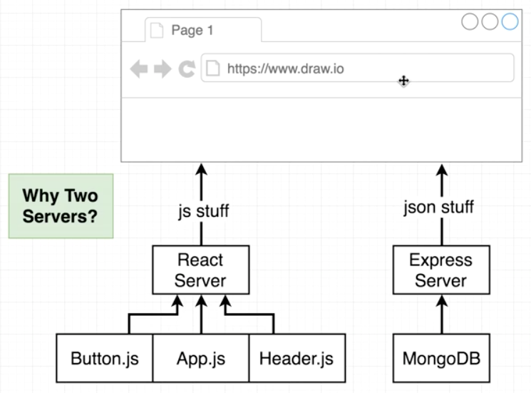

** one server for front-end and the other for data

**Why two servers?**

Create-react-app has prebuilt configurations that will save us time, because it rewires webpack, babble, dev server, etc…

Now all we have to do is make the react server and express server work together nicely.

**Running the Client and Server** (front-end and back-end server)

1. Open new terminal window so one is in server dir and the other is in client dir
2. In client dir terminal: **npm start**
3. In server dir terminal: **npm run dev** (starts up nodemon)

**Run both concurrently:**

1. In server dir terminal: **npm install --save concurrently**
2. In package.json file for server dir (both server and client will be started up by dev script:

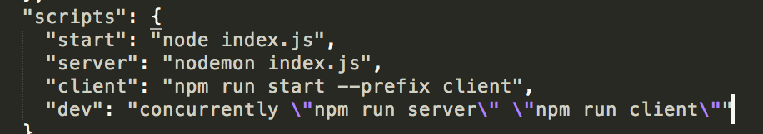

1. In server dir terminal: **npm run server**

**Routing Stumbling Block**

Get link to appear on screen of React boilerplate and kick into OAuth flow, in **app.js**:

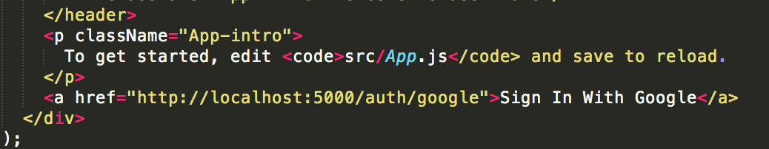

** can’t use relative path here (will navigate to localhost:3000 instead)

*** will only work with **DEV SERVER**

We want to use the **relative path**, however, so delete the <http://localhost:5000/> part.

To fix stumbling block, so relative path will work with both production and dev servers: In **package.json** in client directory, add a proxy property (proxy included with React app):

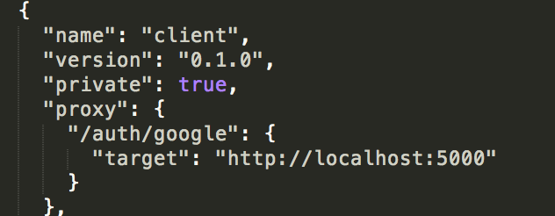

** will have to restart server, as client server doesn’t reload dynamically

**The Beauty of Create React App’s Proxy**

This error will appear after kicking in the OAuth flow:

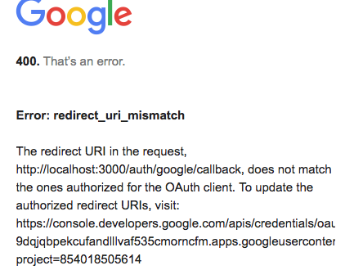

To fix:

1. Go to: **console.developers.google.com**
2. In *emaily-dev*, go to API and add: [**http://localhost:3000/auth/google/callback**](http://localhost:3000/auth/google/callback)to ‘Authorized redirect URIs’

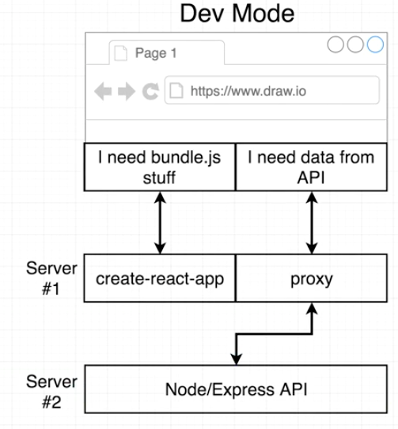

** in production, the create react app server doesn’t exist, so package.json doesn’t need Heroku link

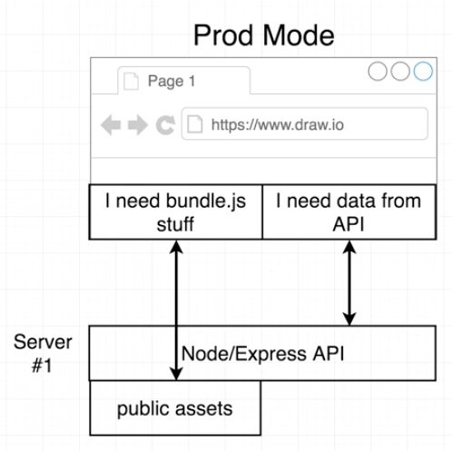

** when we build our react project (entire project), create react app, will take all the JS/CSS/etc… (all assets), and save to ‘build’ folder in ‘Client’ as a new JavaScript file (and other assets)

**To build:**

In terminal (in client directory): **npm run build**

** No longer do we have to run the create-react-app. We just have to build one time and commit, deploy, and leave it to the Express server to serve up all the JS files. Create-react-app server does NOT exist in production.

**Optional: Why this architecture?**

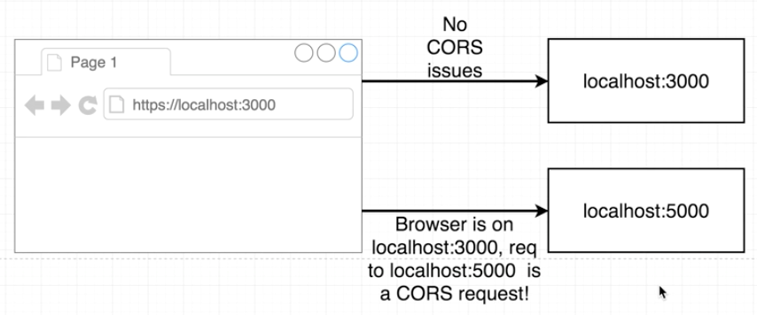

** Same domains, we can make AJAX requests no problem. Also, cookies are provided, no problem. Making requests to different domains, the browser assumes you are doing something malicious. Also, cookies are not provided by default.

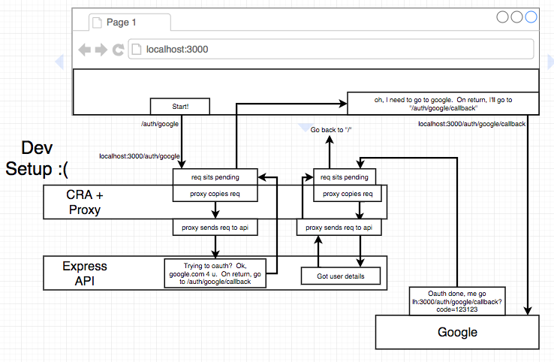

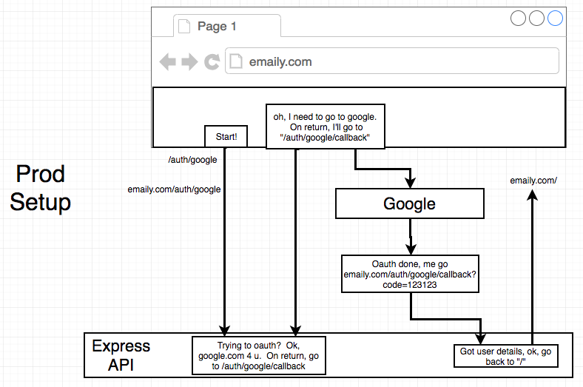

**Developing the Client Side**

**Async/Await Syntax**

**Fetch (e.g. old way):**

function fetchAlbums() {

**// whenever we make a request with fetch, it returns a promise**

**// that promise is resolved with an object that represents underlying request**

**// to get a notification that the promise was resolved we chain on a .then()**

fetch('http://rallycoding.herokuapp.com/api/music_albums')

.then(res => res.json())

.then(json => console.log(json));

}

fetchAlbums();

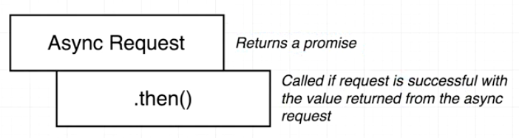

** .then() responds with the callback

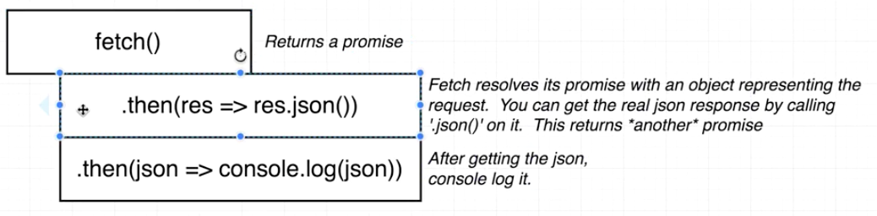

**Fetch (e.g. new async/await way).** Identify any function in codebase that uses some type of async code or some type of promise inside it:

**// or const fetchAlbums = async () => {**

async function fetchAlbums() {

const res = await fetch('https://rallycoding.herokuapp.com/api/music_albums');

const json = await res.json();

console.log(json);

}

fetchAlbums();

**Refactoring with Async/Await**

Before:

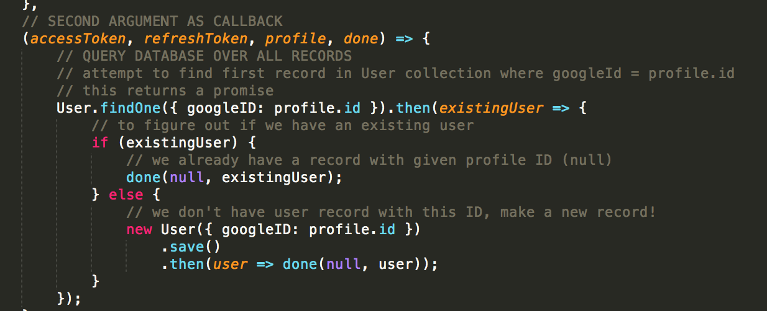

After:

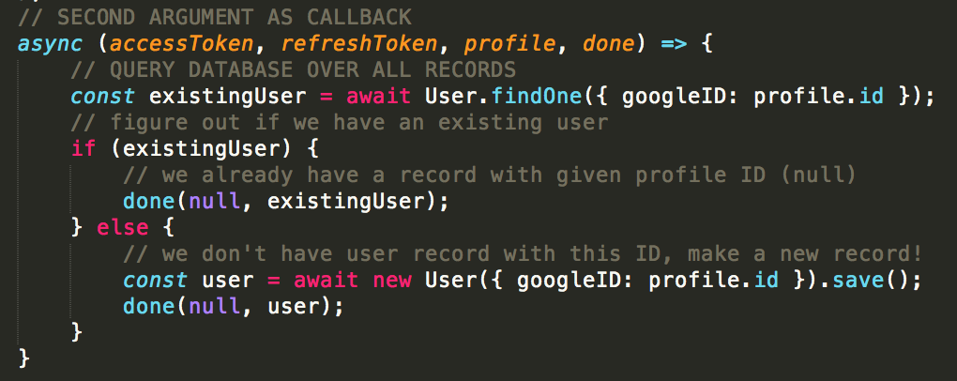

Or we can remove the else by adding “return done” if existingUser:

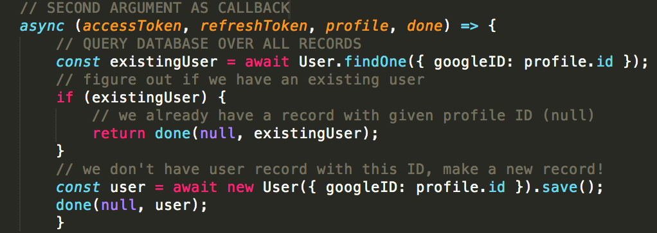

**Front End Tech**

|  |  |
| --- | --- |
| ../../../../../../../Desktop/Screen%20Shot%202018-06-25%20at%2010.1 | ../../../../../../../Desktop/Screen%20Shot%202018-06-25%20at%2010.2 |

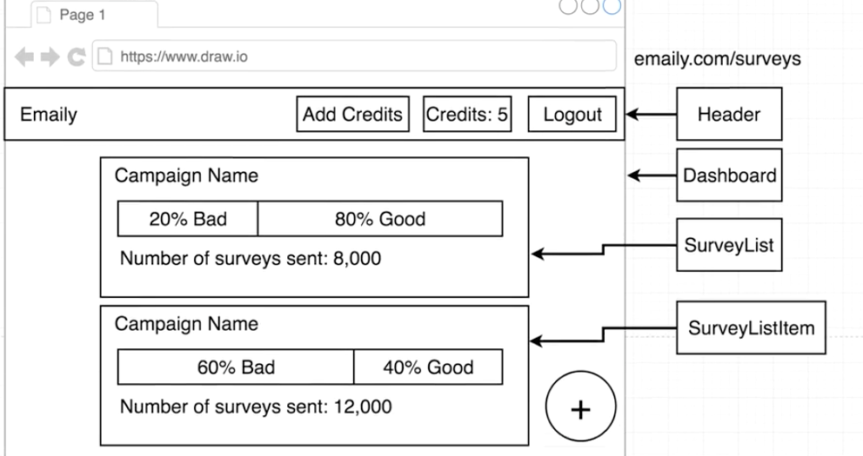

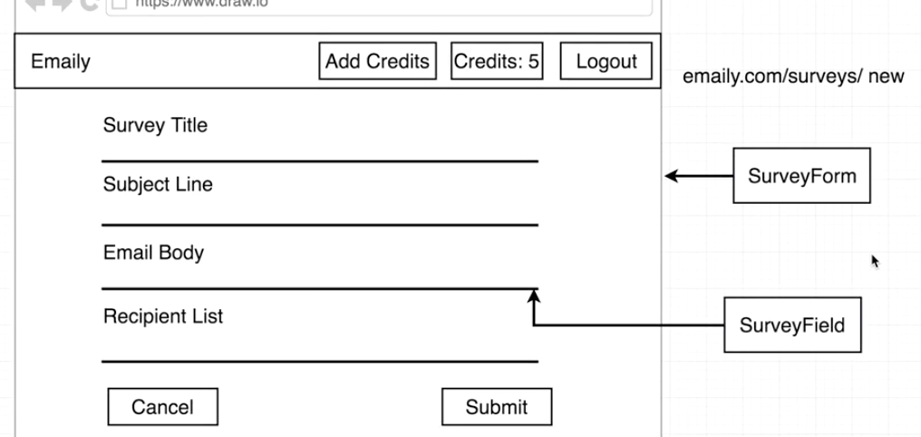

**Client React Setup**

|  |  |
| --- | --- |
| ../../../../../../../Desktop/Screen%20Shot%202018-06-26%20at%2010.4 | * Index.js will contain the initial bootup logic for the React and Redux side of app * It’s really going to be all about Redux * App.js will be mainly concerned with the React and rendering layer of app (what set of components to show on screen) |

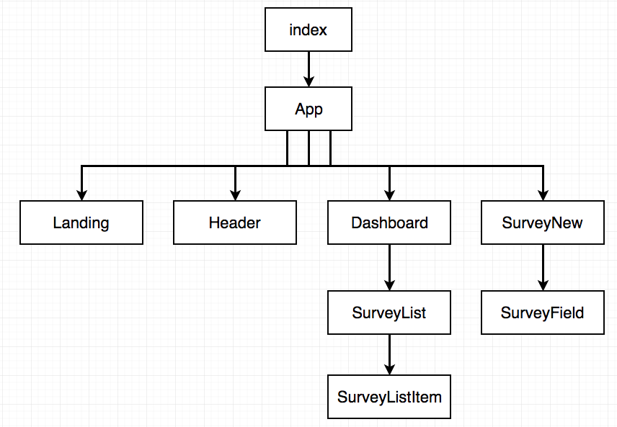

1. In **client**/**src** directory, delete all files except for ‘**registerServiceWorker.js’**
2. In terminal: **cd client**
3. **Npm install --save redux react-redux react-router-dom**
4. Create new file in **client/src** called: **index.js**
5. In **client/src** create new folder: **components**
6. **Cd components**
7. Create new file: **App.js**

** if file is exporting a component or class, label with capital letter

1. In **App.js:**

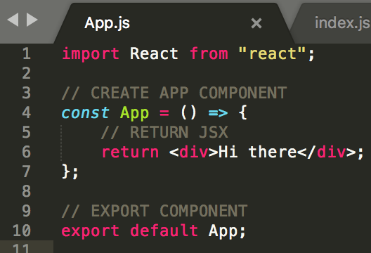

1. In **client/src/index.js** file:

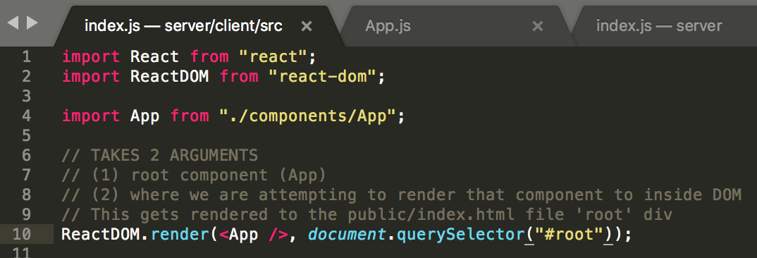

1. Error will appear when **npm run dev** in server dir:

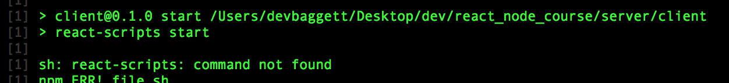

1. To fix error:

* **cd client** dir
* Delete **package-lock.json** file
* **npm install** (in client dir)

1. Verify error is fixed by running: **npm run dev** (in server dir)

**Redux Review and Setup**

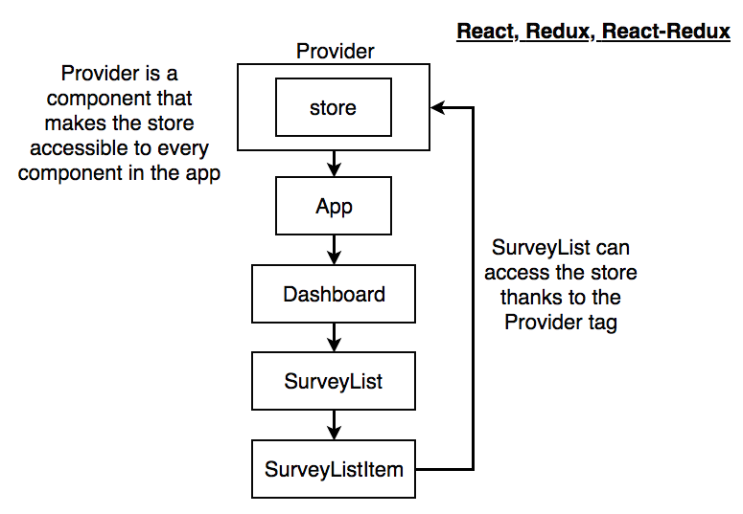

|  |  |
| --- | --- |
| ../../../../../../../Desktop/Screen%20Shot%202018-06-26%20at%2011.2 | Redux Store – where all of our state exists  To determine/or change state we call an action creator which dispatches an action that is sent to all the reducers |

|  |  |
| --- | --- |
| ../../../../../../../Desktop/Screen%20Shot%202018-06-26%20at%2011.2 | ../../../../../../../Desktop/Screen%20Shot%202018-06-26%20at%2011.3 |

**Create Redux store and wire store to component hierarchy with provider tag provided by Redux library:**

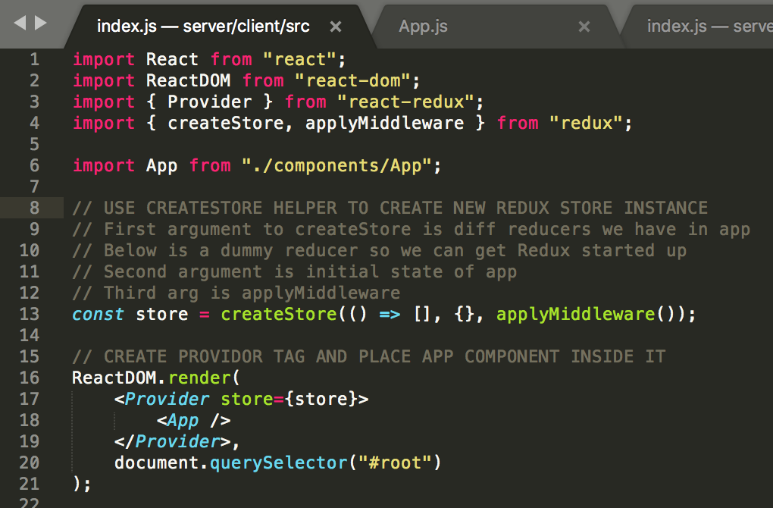

**Create Auth Reducer**

**Create reducer used in Redux store:**

1. **Client/src 🡪** create new folder: **reducers**
2. **cd reducers** 🡪 create 2 new files: **index.js** **authReducer.js**
3. **authReducer.js:**

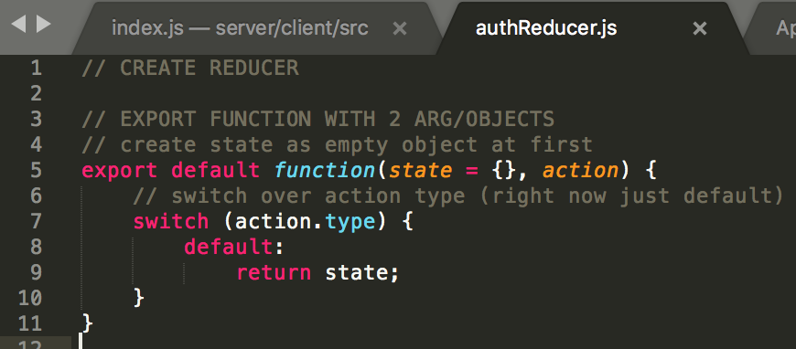

1. **client/src/reducers/index.js:**

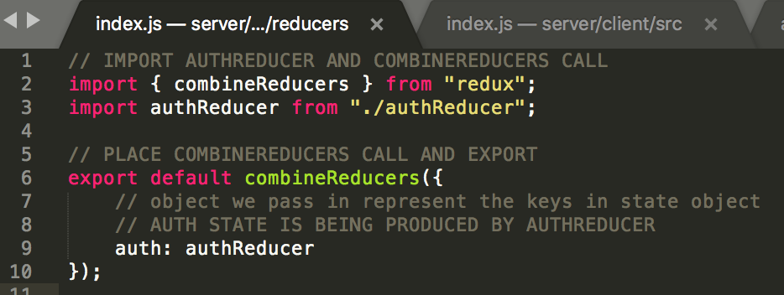

1. Import above reducers and pass off to createStore call. In top-level **client/src/index.js:**

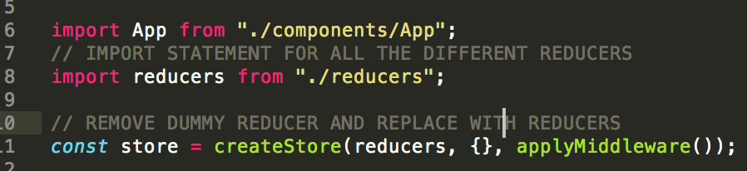

**React Router Setup**

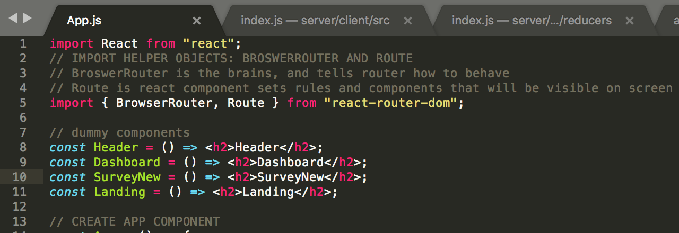

**Route Configuration**

App.js:

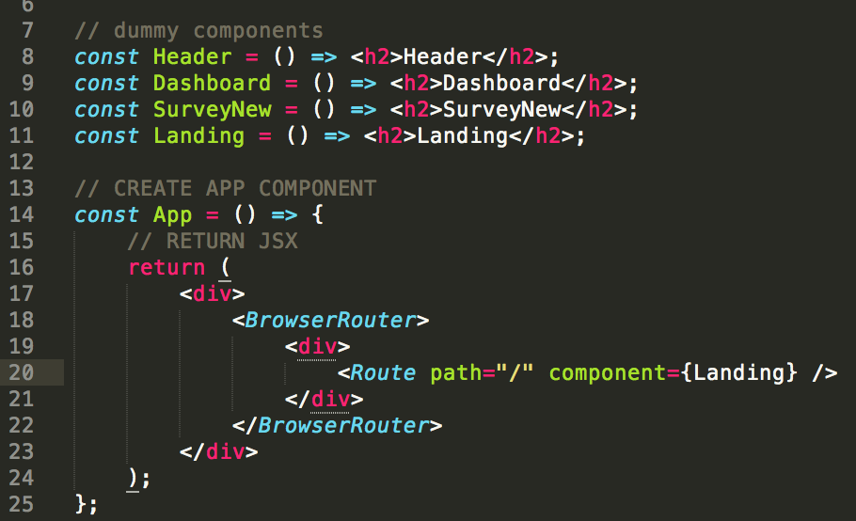

**Always Visible Components**

** Problem 🡪 will display both routes, not one or the other:

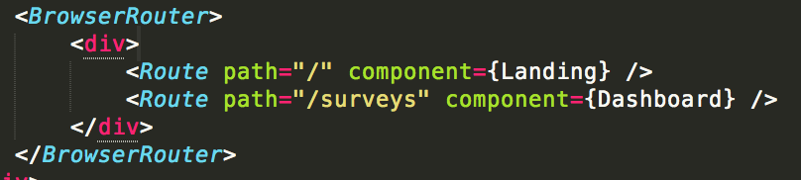

Fix with **exact** routing:

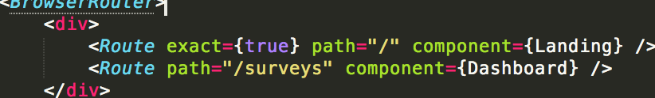

Which is the same as:



Show header at all times:

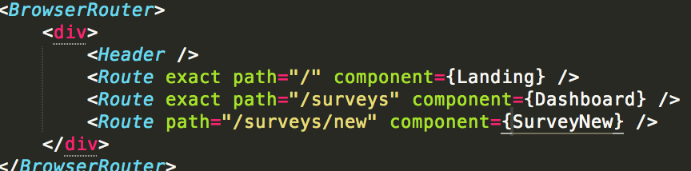

**Materialize CSS**

**Splitting components up (*make header component dynamic*):**

1. In **client/src/components** create new file: **Header.js**
2. In **Header.js**:

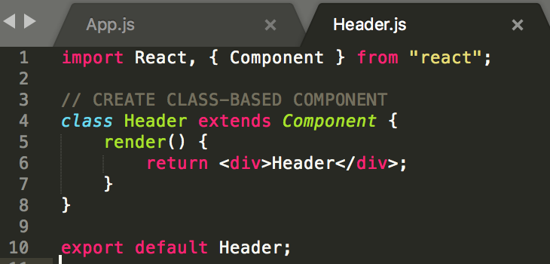

1. In **components/App.js** import and replace dummy Header:

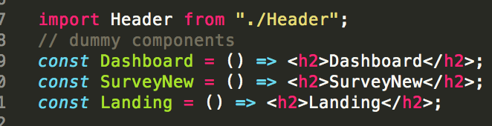

1. Navigate to <https://materializecss.com/> (front-end framework):

* Click ‘Getting Started’ on left navbar
* In **server/client** dir, install with NPM: **npm install --save materialize-css**

**Webpack with CSS**

|  |  |
| --- | --- |
| ../../../../../../../Desktop/Screen%20Shot%202018-06-26%20at%208.1 | * Webpack is a module loader * Arranges files so it spits out one or few output files * Load up ‘loaders’ that instructs it how to handle other file types, other than JS (e.g. CSS) |

Write an import statement that will require in **client/node_modules/materialize-css/dist/css/materialize.min.css** in **client/src/index.js:**

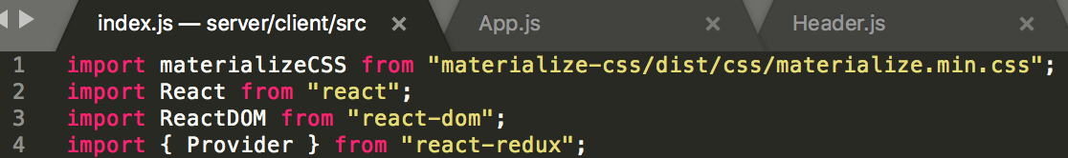

** no need to specify a path; webpack assumes that you’re trying to install an NPM module

*** ***import "materialize-css/dist/css/materialize.min.css****"* will work also

**Header Design**

1. In materialize website, navigate to ‘Components/Navbar’ and reference code for **Logo**
2. In **Header.js:**

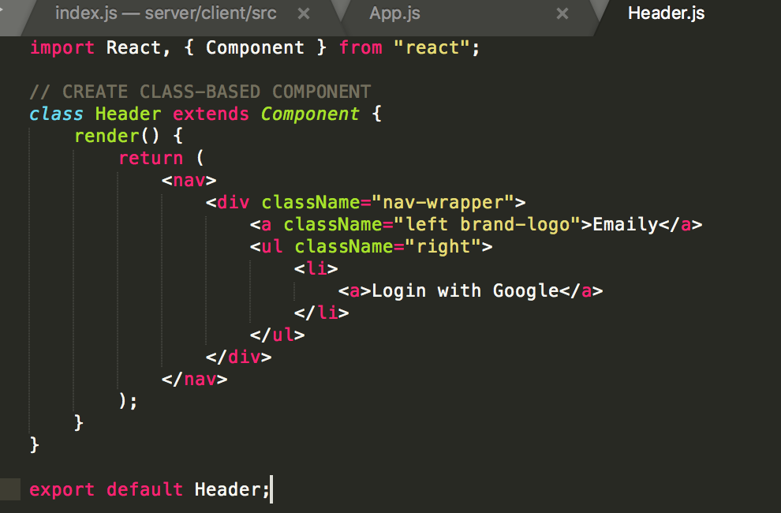

** use **className** instead of **class** with React

1. Since materialize assumes there is a wrapper, in **components/App.js**, add a container:

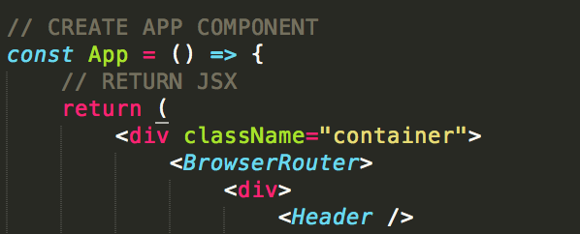

**Current User API**

**How do we figure out if current user is logged in?**

* Already in **server/routes/authRoutes.js**:

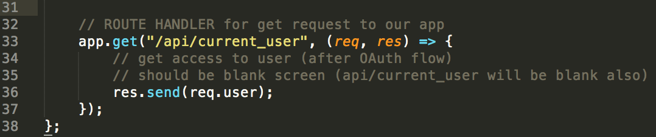

* The instant the server boots up we make an API request to determine whether the user is signed in or not.

**Additional Proxy Rules**

|  |  |
| --- | --- |
| ../../../../../../../Desktop/Screen%20Shot%202018-06-26%20at%209.1 | We want to now create an action creator that makes an AJAX request to the above route handler (back-end) |

|  |  |
| --- | --- |
| ../../../../../../../Desktop/Screen%20Shot%202018-06-26%20at%209.1 | Axios library – responsible for helping us make API/AJAX requests to back-end API  Redux Thunk – helpfully maintain, make asynchronous action creators behave the way we expect |

**Install and import Axios and Redux Thunk libraries:**

1. **cd client**
2. **npm install --save axios redux-thunk**
3. In **client/src/index.js**, import and add to **applyMiddleware:**

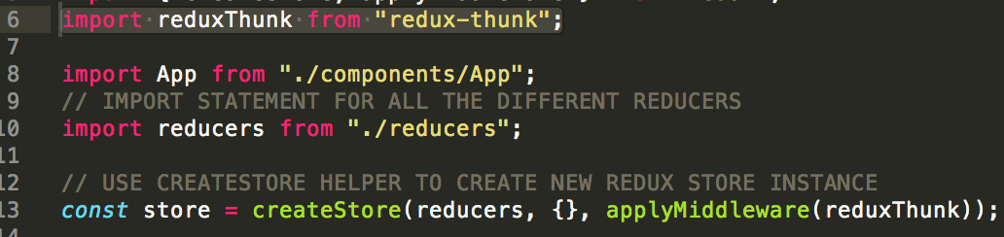

1. To create an **action creator**, create a new folder inside **client/src** directory: **actions**
2. **cd actions**
3. Create 2 new files: **index.js types.js**
4. In **types.js**:

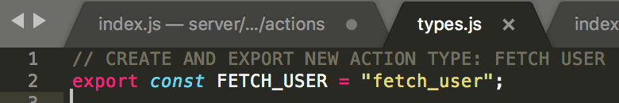

1. In **index.js:**

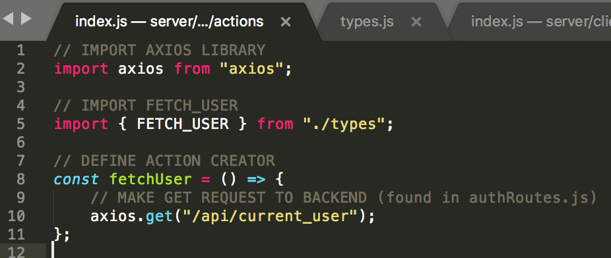

1. Navigate to **package.json** file inside **client** project to make sure we already have a proxy rule for handling the above request and sending to Express backend. Append a second proxy rule which will catch every request that goes to **api/\***:

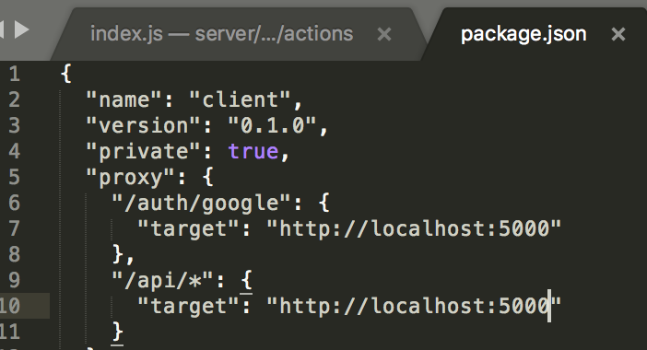

**Basics of Redux Thunk**

** ***An action creator always expects us to return an*** ***action*** (JS object with type project and optionally as a payload).

*** The entire purpose of **Redux Thunk** is to allow us to write action creators that break the rule above. That is, rather than **return** an action, it **produces** one. Redux Thunk gives us direct access to the **dispatch function.**

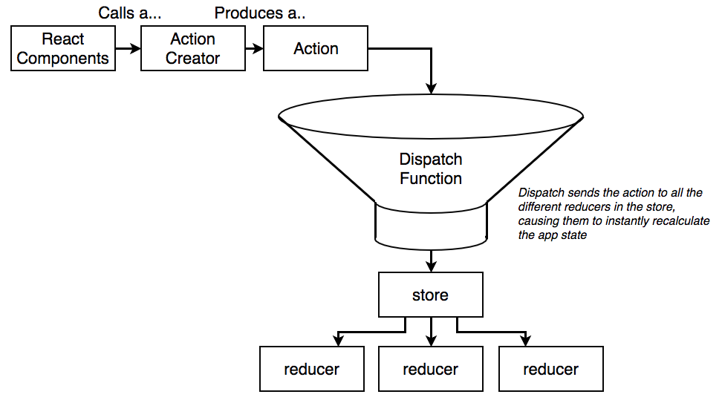

1. If Redux Thunk sees that we return a function instead of a normal action, it will automatically call that function and pass **dispatch function** as an argument.
2. We want to dispatch an action after the get request has been successfully completed. That’s the whole point.

**Create action creator that makes use of Redux Thunk (version 1):**

In **client/src/actions/index.js:**

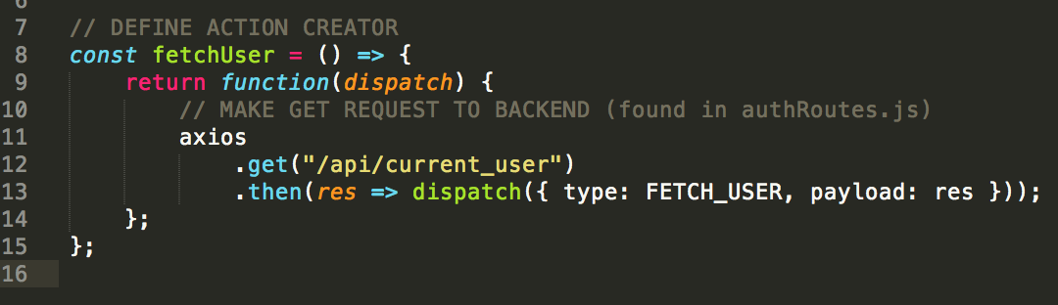

**Refactoring the App**

(instead of functional, we make it class-based instead)

**Where should we add the action creator to?** App component (client/src/components/App.js)

1. Modify import statement to pull in component-based class:

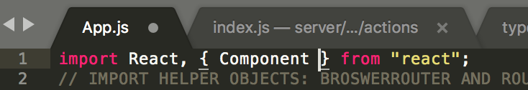

1. Refactor functional component over to a class-based one. Instead of:

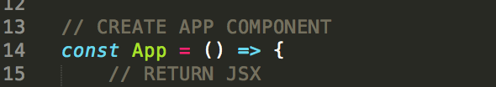

Rewrite to:

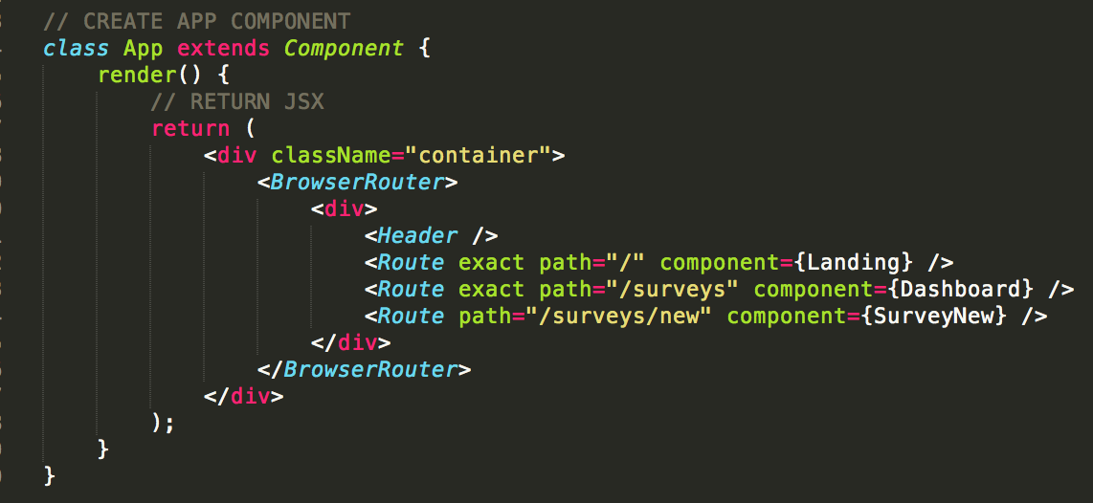

**Testing Fetch User**

**In App.js:**

1. To get redux to work with react we import **react-redux** library. We make use of the **connect** function to give certain components the ability to call **action creators**.
2. Import **all** the different **action creators** from **actions/index.js** file.

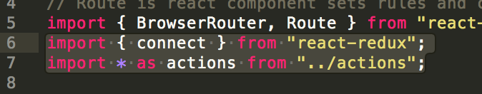

1. Export, 2nd argument is for all the different action creators we want to wire up:

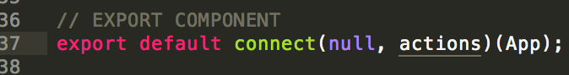

1. Inside app component, we can call our action creator by referencing **this.props.**<name of action creator>:

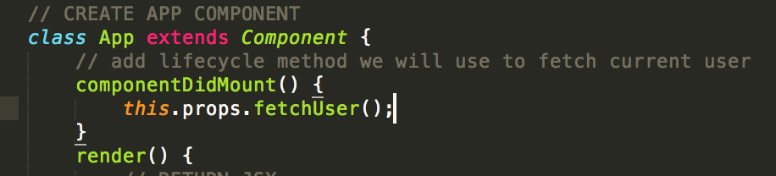

1. Make sure we have some way to verify and test that the data that says the user is logged in gets communicated to our reducer. In **client/src/reducers/authReducer.js**, **console.log** every action the reducer gets called with:

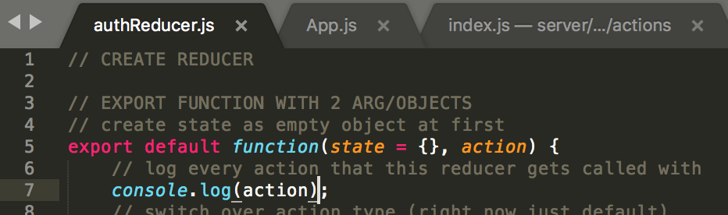

1. **npm run dev** should produce this error:

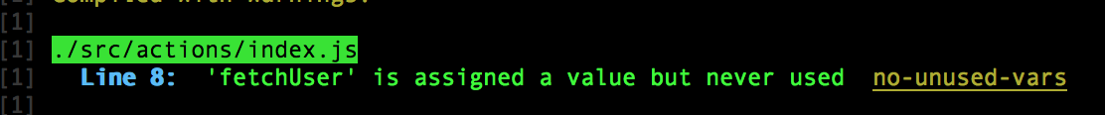

1. To fix, we need to export the variable in **src/actions/index.js:**

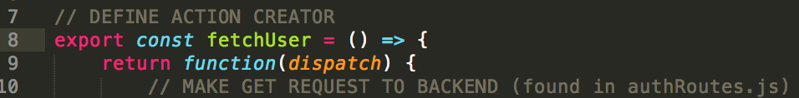

1. When we **npm run dev** we should see 4 console.logs in browser console: 1 console.log from every action that comes into that **authReducer**. We only really care about the 4th one, which tells us whether or not the user is signed in. It shows that Redux Thunk worked correctly to make the request:

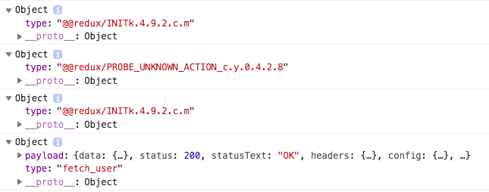

1. Inside the **payload** object is the **axios** response object. The **data** property communicates back the JSON that the server sent us:

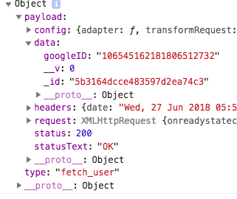

**Refactoring to Async/Await**

Currently, **client/src/actions/index.js**:

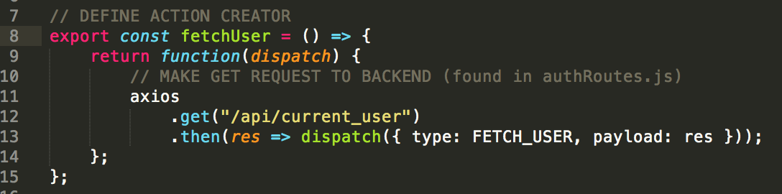

**Create action creator that makes use of Redux Thunk (version 2):**

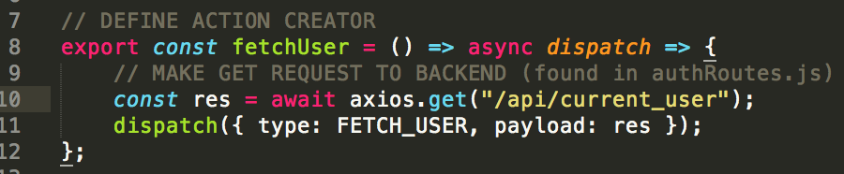

**AuthReducer Return Values**

Rather than return the whole **payload: res** we will just return the **res.data** property as that’s all we care about.



**3 Different cases:**

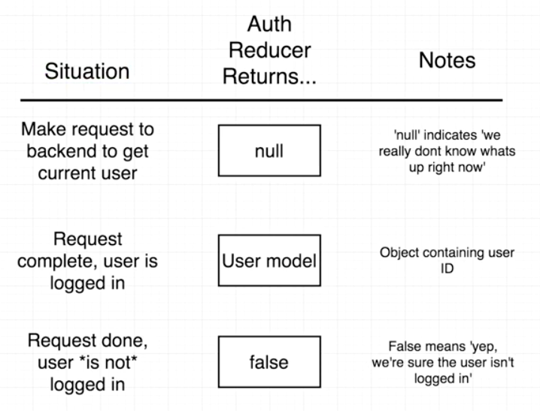

Modify **authReducer.js** to make sure it returns 1 of 3 values: null, false, or user model:

1. Import FETCH_USER action type
2. Change **state** from being empty object **{}** to **null**
3. Add case for FETCH_USER
4. Return user model or false

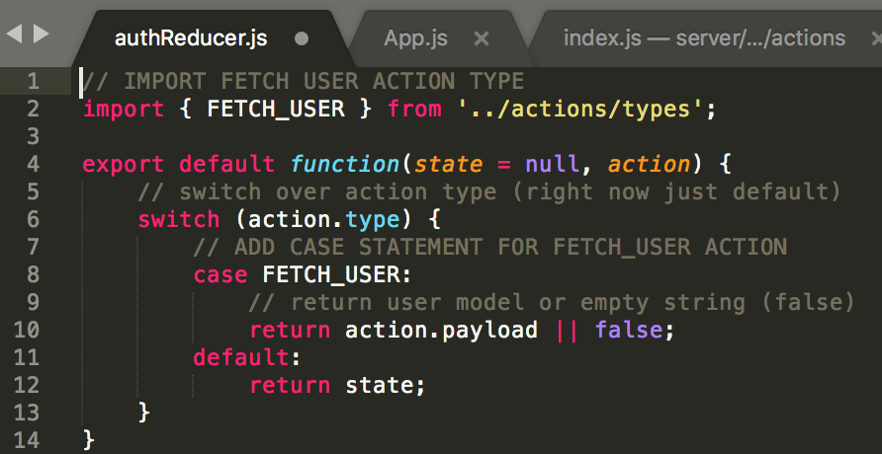

**Accessing State in the Header**

Make sure header knows whether or not the user is logged in (pull auth part of state). In **header.js:**

1. Import *connect* helper from react-redux:

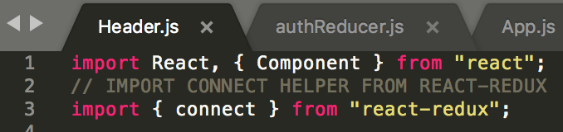

1. Connect to *header* and create function that returns the property **state.auth** (*authReducer* was assigned to *auth* property in ***reducers/index.js***):

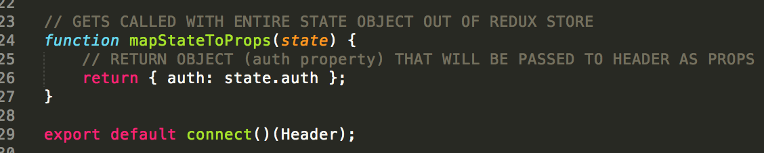

or simplified and refactored:

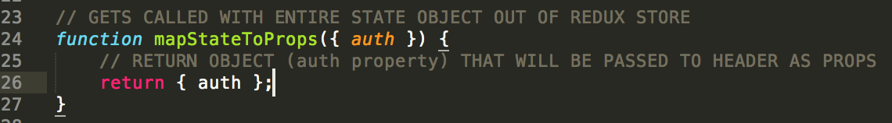

1. Pass *mapStateToProps* as first argument in connect function:



1. Test using a console.log to look at entire props object:

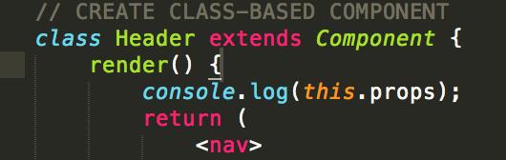

Should see 2 logs.

|  |  |
| --- | --- |
| Logged in:  ../../../../../../../Desktop/Screen%20Shot%202018-06-27%20at%201.4 | Logged out:  ../../../../../../../Desktop/Screen%20Shot%202018-06-27%20at%201.4 |

1. Use **props.auth** property to show what content to show inside header

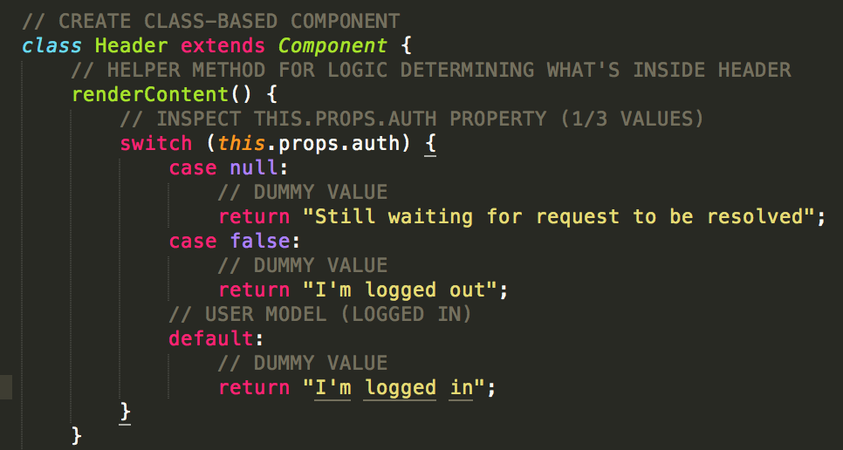

1. Replace **ul** with **renderContent()** call:

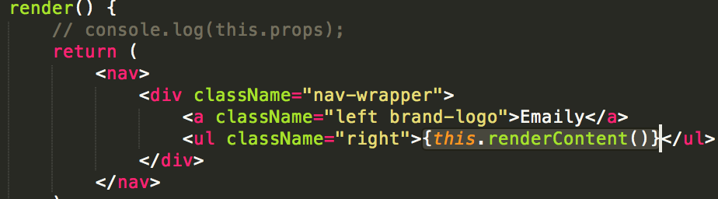

1. After testing network throttling speeds of switch case, for **null** return nothing, return a link for **false**, and a dummy link for **default**:

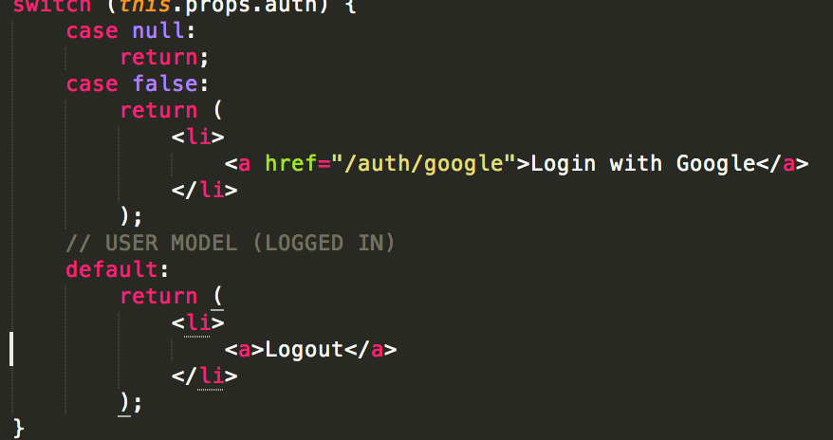

**Redirecting a User on Auth**

The below 3 middleware instances intercept every incoming request, however, they can be set to look at individual requests as well. **Server/index.js:**

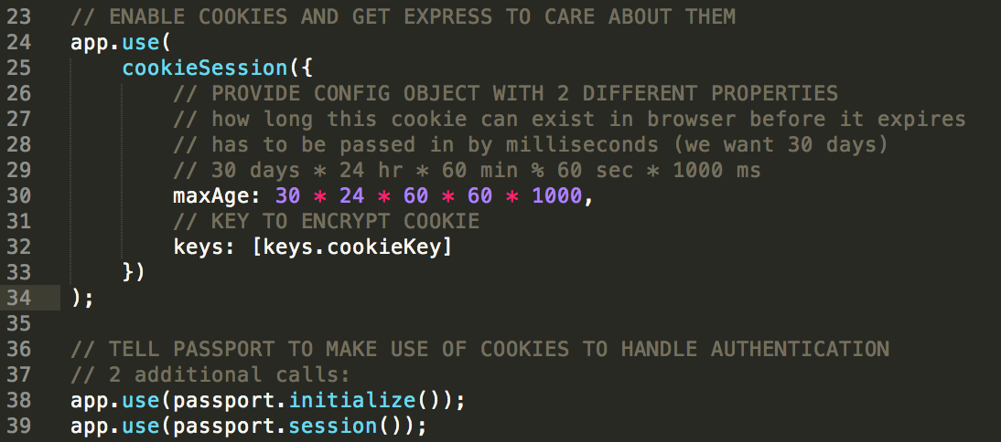

In **server/routes/authRoutes.js:**



** passport.authenticate(“google”) is a **middleware** and function that takes the incoming request and further authenticates the user by taking the code out of the URL and fetching the user’s profile, and then it calls the callback in the google strategy. After that, it passes the request on to the next middleware inside the flow.

Modify by adding on another route handler for **redirect** to *dashboard*:

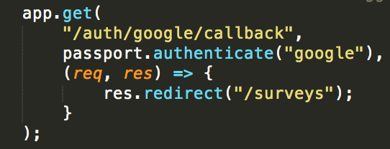

**Redirect on Logout**

Have to empty the server cookie on logout.

**Are we going to:**

1. **Make an AJAX request that’s going to go to that logout route?**
2. **Make this in a traditional anchor tag that will cause the entire browser to go to the logout route and kick the user to somewhere back inside the app?**

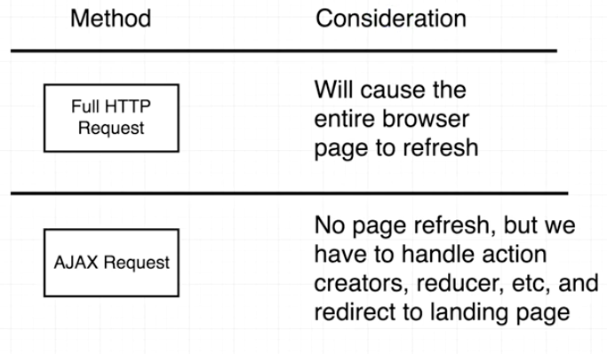

** AJAX request is a lot faster because the browser isn’t changing HTML documents.

** With HTTP request, browser really doesn’t care about speed after logging user out.

**HTTP Request:**

1. Set the href for logout:

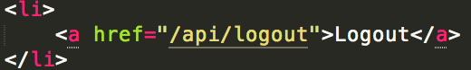

1. Back-end redirects user to landing page after logout. In **authRoutes.js**:

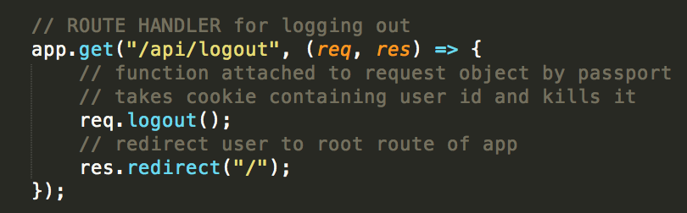

**Landing Component**

1. In **client/src/components**, create a new file: **Landing.js**
2. Create boilerplate:

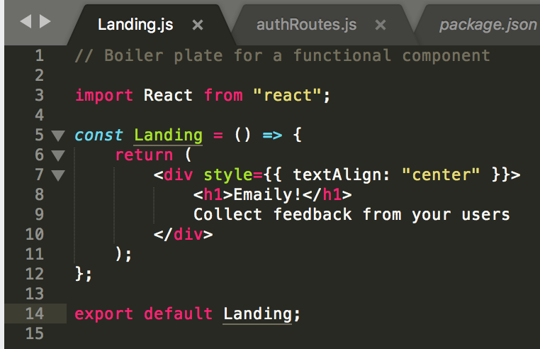

1. Delete landing dummy component from **components/App.js** and import:

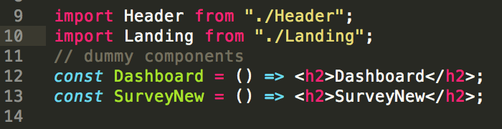

**Link Tags**

Setup where if the user is logged in and they click on “**Emaily**” in top Header, it takes them to dashboard, and if they’re logged out, it takes the instead to the landing page.

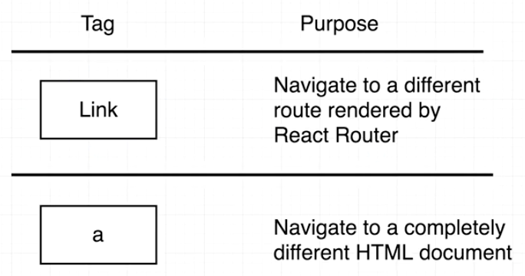

**In Header.js**:

1. Import **Link tag**:

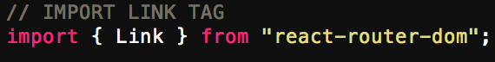

1. Write logic so that if ***this.props.user*** exists, go to **surveys**, otherwise go to **“/”** root:

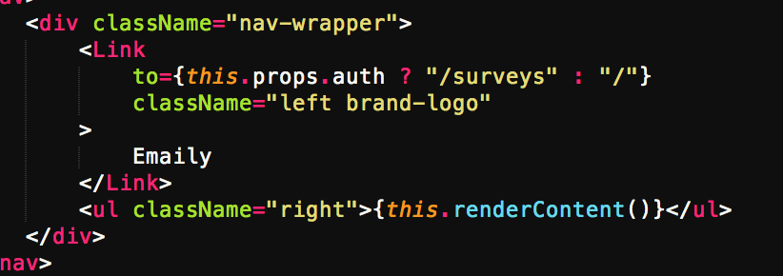

**Handling Payments**

**Client Side Billing**

|  |  |
| --- | --- |
| ../../../../../../../Desktop/Screen%20Shot%202018-06-27%20at%208.3 | Green 🡪 backend  Blue 🡪 client-side |

**Billing Considerations**

After user clicks “Add Credits” they get routed below:

|  |  |
| --- | --- |
| ../../../../../../../Desktop/Screen%20Shot%202018-06-27%20at%208.4 | ../../../../../../../Desktop/Screen%20Shot%202018-06-27%20at%208.4 |

** use outside-payment processor **STRIPE** (stripe.com)

*** for plans use **Recurly**

**Stripe Billing Process**

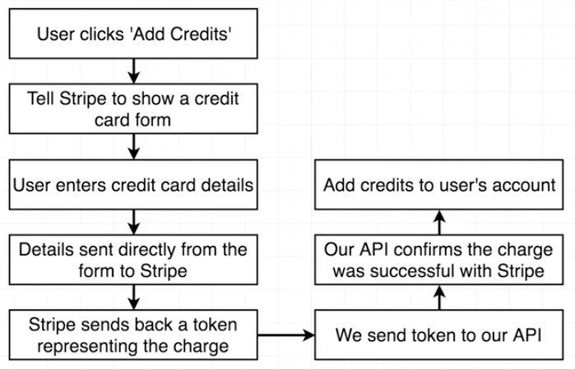

**Exploring the Stripe API**

**Stripe Dashboard/developers/API keys:**

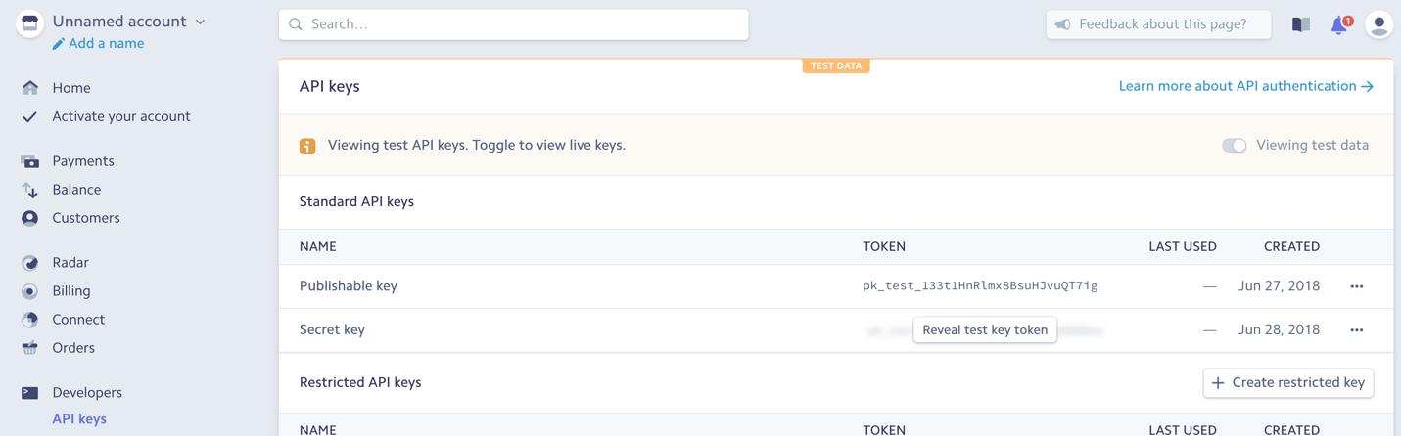

* **Publishable key** can be published to outside world. Used to identify our app to Stripe and we’ll use it on front-end/back-end of app.
* **Secret key** we don’t want to share with anyone – will be used on back-end
* Keys only to be used by our back-end server in **config** direct

**Stripe plugin/library we’re going to be making use of to show a credit card form to users:**

1. Google search: **stripe checkout**
2. The one we’re actually going to be using is for react; google search: **stripe checkout react** (should be GitHub – azmenak link)
3. Install as NPM module: **cd client 🡪 npm install --save react-stripe-checkout**

**Stripe API Keys**

Run server: **cd ..** 🡪 **npm run dev**

Note about config keys:

1. **dev.js** keys has all raw keys intended for use in the dev (server-side) environment
2. **prod.js** pulls keys from our Heroku environment variables

**Server side:**

1. Copy **publishable key** and paste in **dev.js**
2. Copy **secret key** and paste in **dev.js**

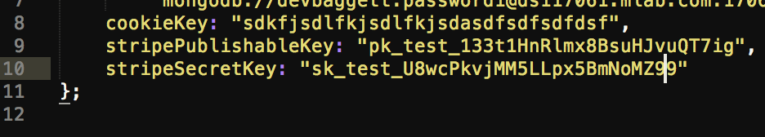

1. Add to **prod.js**:

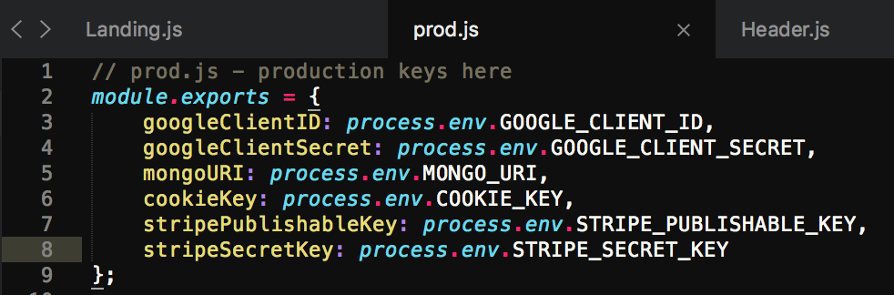

1. Make sure that the Heroku environment has keys set up correctly:

* Go to Heroku.com
* Click on the associated app
* Click ‘Settings’ in navbar
* Click ‘Reveal Config Vars’

1. Add both publishable and secret key to list:

* Copy property names from **prod.js** (i.e. STRIPE_PUBLISHABLE_KEY, STRIPE_SECRET_KEY
* In Heroku Config Vars 🡪 paste as new keys
* Copy and paste publishable/secret key tokens as values, respectively:

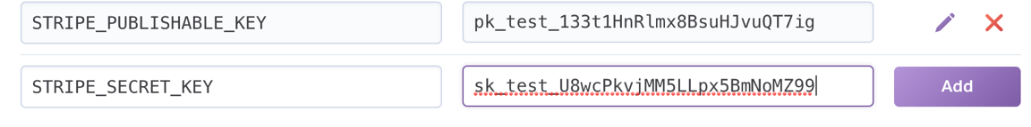

* Make sure to ‘add’

**Env Variables with React**

Define the Stripe key as an **environment variable:**

1. Google: **create react app environment variables**

(https://github.com/wmonk/create-react-app-typescript/blob/master/packages/react-scripts/template/README.md)

1. Click and scroll down to: **Adding Custom Environment Variables**

*(Note: You must create custom environment variables beginning with****REACT_APP_****. Any other variables except NODE_ENV will be ignored to avoid accidentally*[*exposing a private key on the machine that could have the same name*](https://github.com/facebookincubator/create-react-app/issues/865#issuecomment-252199527)*. Changing any environment variables will require you to restart the development server if it is running.)*

1. We’ll be using: **Adding Development Variables In .env**:
2. In **client** dir, create 2 files: **.env.development .env.production**
3. Copy **publishable key**
4. Assign and paste in both of the above created files as follows (and save):

**REACT_APP_STRIPE_KEY=pk_test_133t1HnRlmx8BsuHJvuQT7ig**

*\*\** ***note****: we are using the same stripe key between both dev/prod because we want to use the same test account, and for the course we don’t want to activate the account*

1. Add both files to .gitignore for **client** dir
2. In **client/src/index.js**, at very bottom console.log to test:

**console.log("STRIPE KEY IS", process.env.REACT_APP_STRIPE_KEY);**

**console.log("ENVIRONMENT IS", process.env.NODE_ENV);**

1. Restart server: **npm run dev**
2. Should see in browser console:

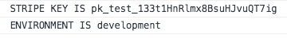

1. Delete console.logs

**The Payments Component**

1. In **client/src/components** create new file: **Payments.js:**
2. Import *StripeCheckout* and set its properties in **Payments.js**:

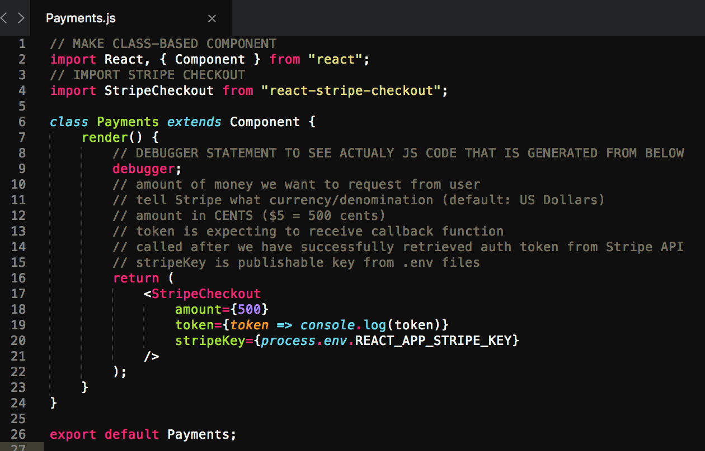

** debugger pauses the code (really does nothing here, the way it was supposed to)

1. Import Payments and show component in **Header.js**:

import Payments from "./Payments";

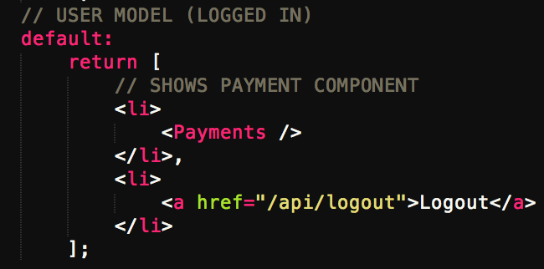

1. **npm run dev** will show payment component now in header
2. Test **credit card** number: **4242 4242 4242 4242**
3. **Expiration**: any date in future
4. **CVV**: any 3 digit number
5. Click ‘**Pay’**
6. Should see token console.logged
7. In next section warning in browser console will be fixed

**Payment Fixes**

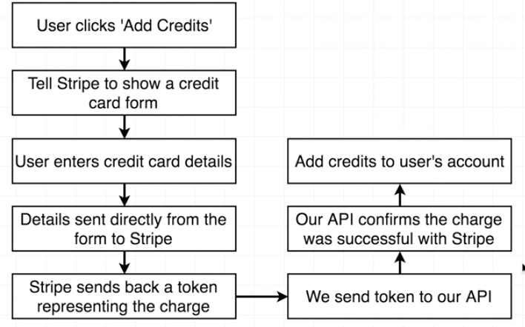

** We now have to **send token back to our API**.

*** Object that stores the credits is the user model.

1. Provide key (has to be unique, and can be whatever we want):

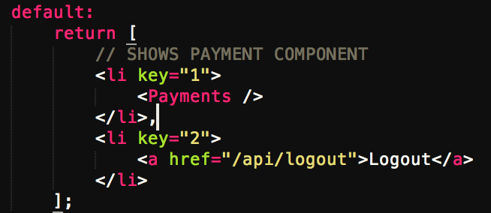

1. Payment modal isn’t clear what user is paying for. To customize text that appears in modal, add *name* and *description* in **Payments.js**:

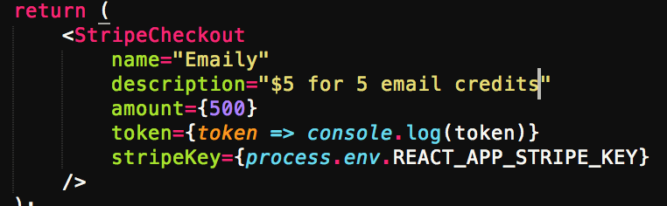

1. Customize *‘Pay With Card’* button in header:

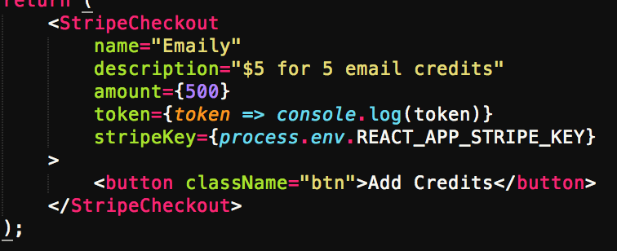

**Reusing Action Types**

|  |  |
| --- | --- |
| ../../../../Screen%20Shot%202018-06-28%20at%205.09.49%20PM.png | When the app boots up we’ll know how many credits to display inside the header.  Whenever a user pays us money and we take the token and send it back to backend API, the API will do the follow up request with Stripe, and after the user has been successfully charged, the server will update the amount of credits the user has and send the current user model with new number of credits.  The authReducer stores user model |

**Create action creator 🡪 client/src/actions/index.js:**

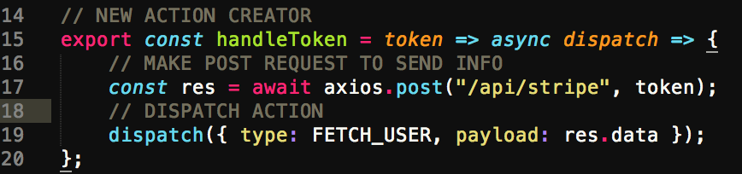

**Posting the Stripe Token**

In **components/Payments.js**:

Import both Connect helper and all action creators.

import { connect } from "react-redux";

import * as actions from "../actions";

Wire up connect helper:

export default connect(null,actions)(Payments);

After we get a token back from Stripe API, we call action creator in **Payments.js**:

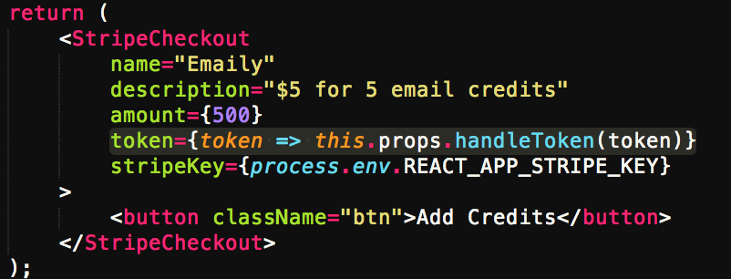

In inspector/network/XHR (filter by), once we click on the *‘Pay’* payment button, we should see the POST request (tokens) made after we go through the add credits process. Should also get a Stripe 404 error. This is because Express API does not have a route handler set up to watch for POST requests to the route */api/stripe.*

**Post Request Handlers**

1. Create file in **server/routes** to handle all the billing related handlers within app: **billingRoutes.js**
2. Create boilerplate arrow function and immediately export. In **billingRoutes.js**:

module.exports = app => {};

1. Require in **server/index.js** file and hook it up with Express app object:

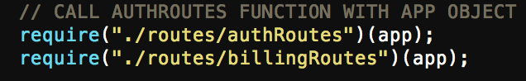

*\*\* this returns a function that we immediately call with the Express app object*

1. Continue setting up **billingRoutes.js:**

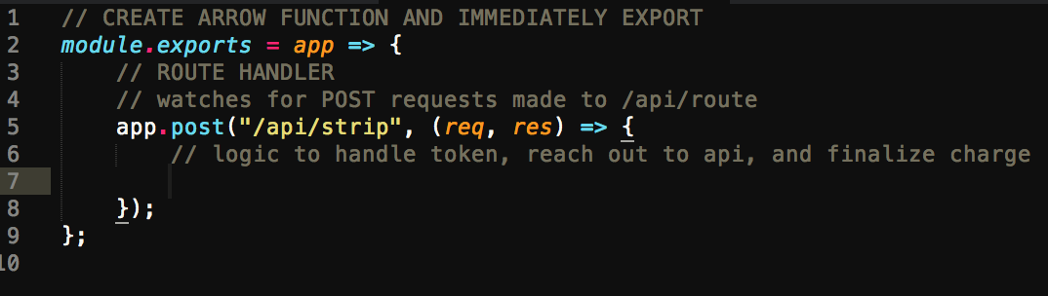

**Creating Charges**

**Install npm module that is use for the server side of app that will help work with Stripe API:**

1. Navigate to **npmjs.com**
2. Search for **Stripe 🡪 Stripe API wrapper**
3. Click on ‘*Node API docs’*
4. On left navbar, click on **Core Resources 🡪 Charges**

**Note:** charge object is returned by the Stripe API. We first have to create a charge object, however, to send Stripe.

1. Navigate down to ‘*Create a charge’*
2. Notice the example code on right that we can copy. **Source** contains a token that we specify where to pull the money from.
3. In **server** dir: **npm install --save stripe**

**BodyParser Middleware**

First, in **billingRoutes.js**, import Stripe at very top of file:

const stripe = require("stripe");

In the second set of parentheses we pass in our secret key, but first we have to require in **keys.js**, right above the require Stripe import:

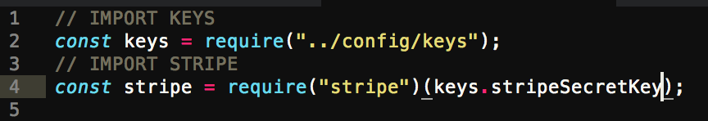

** *stripeSecretKey* can be found in **prod.js**

**Stripe** object contains the credit card info/tokens:

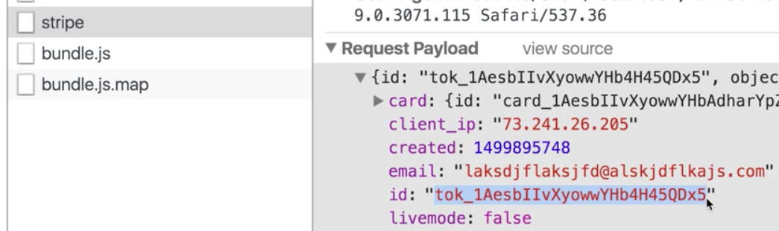

**\*\* When you make POST requests to an Express server, Express does not by default parse through the request *payload***

**Install and import BodyParser:**

1. Inside terminal in **server** dir: **npm install --save body-parser**
2. Require in to **server/index.js**:

const bodyParser = require("body-parser");

1. Above the CookieSession app.get, wire up bodyParser middleware:

app.use(bodyParser.json());

*\*\* Now any time a request comes in that has a request body,* ***body-parser****, will parse the body and assign it to the* ***req.body*** *property of the incoming request object.*

**Creating a Charge Object**

1. Test the POST request **body.req** value, in **billingRoutes.js:**

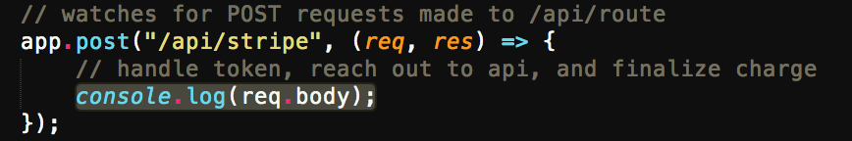

1. Write the logic for handling the token to finalize charge:

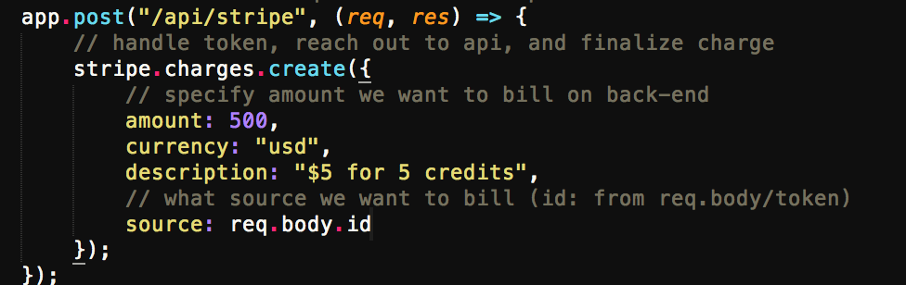

*\*\** ***Note****: charges on front-end and back-end have to match up as to confirm the right amount is charged*

**Finalizing a Charge**

**From Stripe API docs:**

Every method returns a chainable **promise** which can be used instead of a regular callback. (to handle the promise we will use **async/await** below)

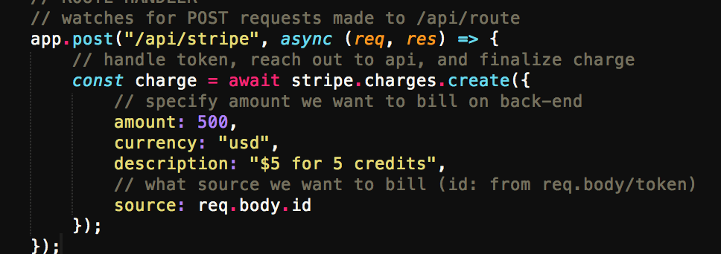

***\*\*Note:*** *c*all that returns a promise, whatever that promise returns, assign it to a variable:

const charge = await stripe.charges.create({

To test, console.log the **charge**:

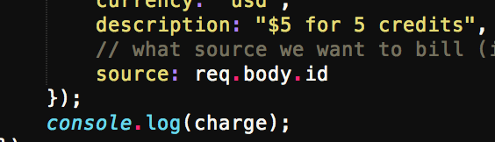

**Adding Credits to a User**

Add another property to user model class: **credits**

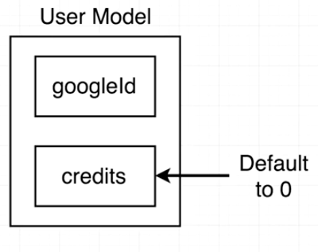

Add credits to *userSchema* in **server/models/User.js**:

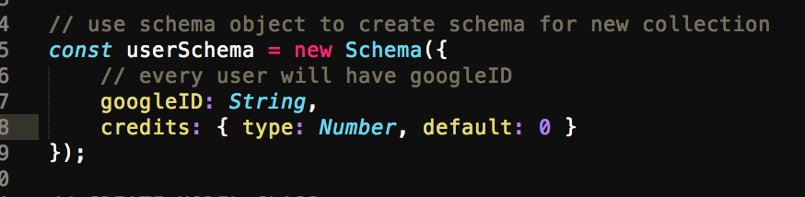

In **routes/billingRoutes.js:**

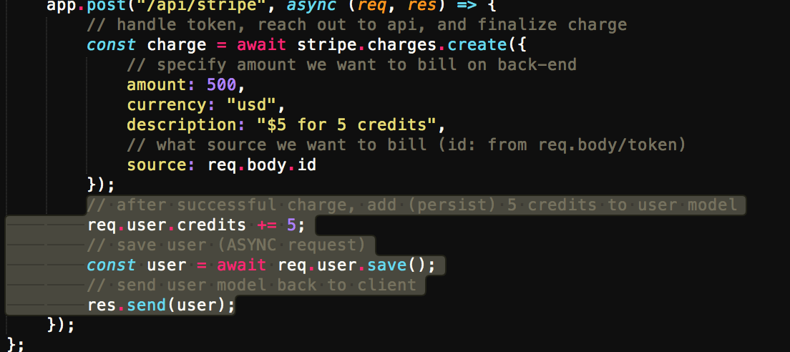

**Requiring Authentication**

Ensuring user is logged in. This can be used on multiple routes. In **billingRoutes.js**:

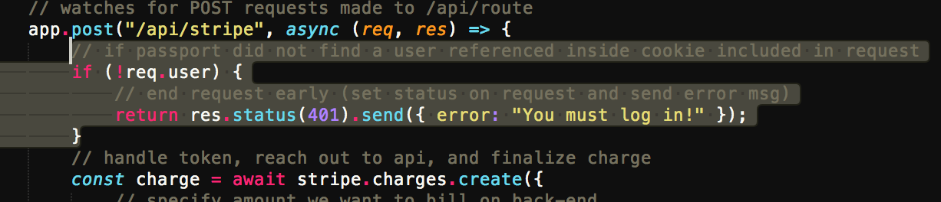

**Route-Specific Middlewares**

|  |  |
| --- | --- |
| ../../../../Screen%20Shot%202018-06-28%20at%208.25.18%20PM.png | Since there might be many routes inside app where we require authentication like above, we will rewrite as to not repeat this logic  Create a new middleware we will use to make sure user is logged into app  Make use of that middleware with only some very particular handlers, specifically the one we want to ensure the users are logged in before they request that given route handler |

1. In **server** dir, create new folder: **middlewares**
2. In **middlewares** create new file: **requireLogin.js**
3. In **requireLogin.js:**

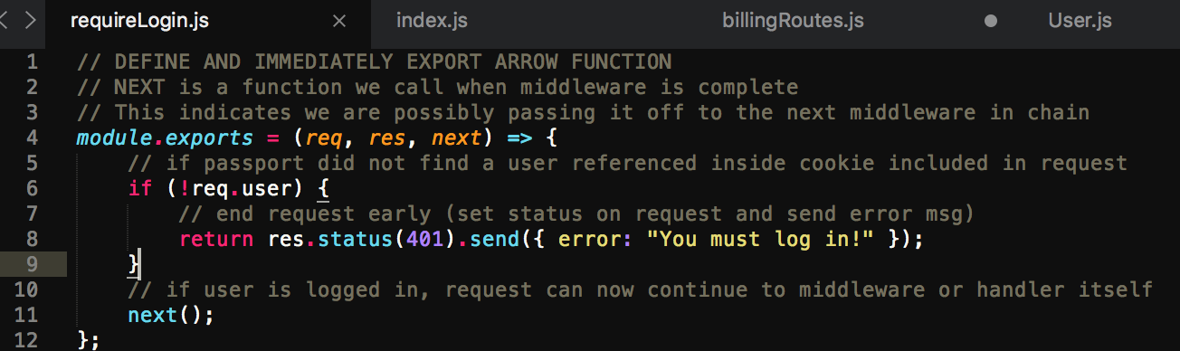

1. Back in **billingRoutes.js**, import **requireLogin.js:**

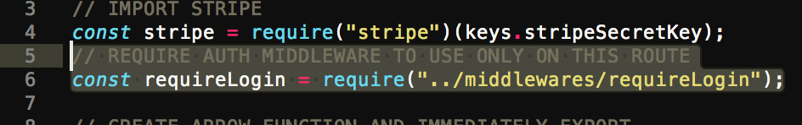

1. In **billingRoutes.js**, create a reference to the **requireLogin** middleware and clean up redundant code:

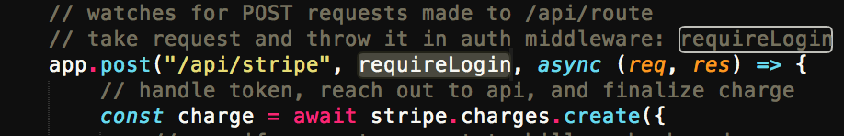

**Displaying Credit Quantity**

In **client/src/components/Header.js**:

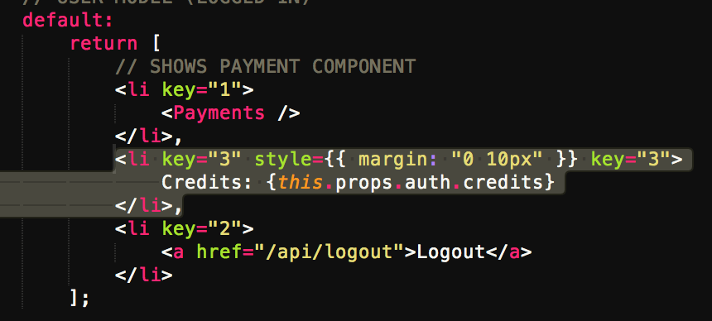

**Updating Credits**

|  |  |
| --- | --- |
| ../../../../Screen%20Shot%202018-06-28%20at%208.56.37%20PM.png | The header text for displaying the number of credits has comes from the property this.props.auth  this.props.auth is being produced by our auth reducer inside our reducers directory |

|  |  |
| --- | --- |
| ../../../../Screen%20Shot%202018-06-28%20at%209.02.21%20PM.png | Any time an action comes across with the type: **FETCH_USER**, we return the action’s **payload** |

In **client/src/actions/index.js:**

|  |  |
| --- | --- |
| ../../../../Screen%20Shot%202018-06-28%20at%209.14.16%20PM.png | 1. Here is our action creator to take a token and send it to our backend API. 2. We know without a doubt that the response to the POST request is the updated user model with the new amount of credits. 3. After we get that response we dispatch an action with type FETCH_USER with that user model. |

It’s solely because we use the same action type between those 2 action creators, and the fact authReducer is watching for that very specific type (FETCH_USER) that the header automatically updates.

**In other words:**

1. We get the response back from the API
2. OK. It can now update the value in the reducer
3. The reducer updates the value
4. It pulls off the new user model
5. Because the authReducer we ran created a new piece of state, redux state updates
6. Because redux state updates, all the components in our app rerenders as well with that new state
7. **this.props.auth** now contains the new user model that just got returned from our API
8. The header updates its text